CubeSat Design, Magnetorquer Design, and Preliminary Bill of Materials.

By Claire Lizotte

Contents

Magnetorquer Design 3

Background 3

Designing the Magnetorquer 5

Final Design 8

Next Steps 9

Magnetorquer Design References 9

Cubesat Structural Design 10

Component Changes: 10

Summary of mechanical constraints from Nanoracks. 11

Things to take into consideration 12

Gold Engraving 21

Manufacturing 23

Assembly 23

Bill of Material (BOM) 32

Budget/Suppliers 32

Mass Budget & Assembly Properties 35

FEA 38

Static Simulation 39

Modal Analysis 43

Conclusion 43

Next Steps 43

Quotes 44

Appendix I: Mechanical Constraints from Nanoracks 46

Appendix II: Electrical constraints from Nanoracks 48

Appendix III: FEA – Static Gravitational Analysis 48

Gravitational Loads in Opposite Direction 67

Static Graviational Study – Report Generated by Solidworks 73

Appendix IV: Modal Analysis 80

Modal Analysis – Solidworks Report 86

# Magnetorquer Design

It was decided to use magnetorquers to control the cubesat’s orientation in space and to detumble the cubesat after launch.

This decision was made by the ADCS capstone team. They proposed an off-the shelf magnetorquer, however, it was decided to make our own as it is a component that we could make, and then we can say that we made our own (which would be cool :p).

So, I designed magnetorquers for the cubesat.

## Background

It is well known that current flowing through a wire produces a magnetic field around the wire. When the wire is coiled, the magnetic field produced by each coil is added together (principle of superposition), which results in the field inside the coil being amplified and the field around the coil being canceled out.

In space, we can use the magnetorquers to control the attitude of the cubesat by activating the coils. They will produce a magnetic field, which will interact with the earth’s magnetic field, producing a torque on the coil, which translates to the cubesat as the coil is fixed to the cubesat. The strength of this torque is defined by equation 1, where M is the resultant mechanical moment, m is the magnetic dipole moment produced by the coil, and B is the earth’s magnetic field.



$\vec{M}= \vec{m} × {\vec{B}}_{earth}$

The magnetic dipole moment produced by a core is a function of the shape of the core (the area the coil encompasses), the current going through it, and the number of loops in the coil, as shown in equation 2.



$m=NIA$

It is important to note that this is the equation for a coil with an air core (no core). The magnetic dipole moment produced increases with a ferromagnetic core.

Now, it was very difficult to actually find a formula to say the effect of the ferromagnetic core on the dipole moment. Eventually we found a paper [1] that states that the dipole moment in the core is:

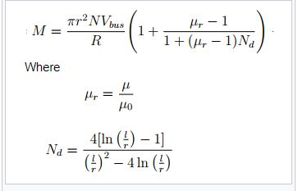

Where:

* M: magnetic dipole moment in the core
* r: radius of the core
* N: number of turns
* R: resistance of the wire
* Vbus: voltage
* μ: permeability of the material
* μ0: permeability of air
* Nd: demagnitization factor
* l: length of core

This formula makes sense and is somewhat consistent with results found in other papers. Another paper said that the magnetic dipole moment of a solenoid with a core was *m=niak*, which is the same as the this formula, as the area, a = πr2, and the current, I = V/r. The rest forms the constant which is the effect of the core.

This formula leads us to look at the resistance of the wire, which is important due to the power constraints of the cubesat.

First, the relationship between power, voltage and resistance is:

$$R= \frac{V^{2}}{P}$$

The resistance of a wire can be calculated using:

$$R= ρLA$$

Where ρ is the resistivity of the material, l is the length of the wire, and A is the cross-sectional area of the wire.

The effect of temperature on the resistance of the wire can be accounted for:

$$R=R_{ref}(1+a\left(T-T_{ref}\right))$$

Where Rref is the resistance of the wire at temperature Tref, R is the resistance at temperature T, and a is the temperature coefficient of resistance of the material. This is important as the cubesat will experience a large temperature range, and the power draw of the magnetorquers must not exceed the limit even at the hotter temperatures.

## Designing the Magnetorquer

First, the constraints were established:

|  |  |  |
| --- | --- | --- |
| Parameter | Value | Max/Min/Equals |
| Voltage | 5V | Equals |
| Power | 200mW | Max |
| Length | 60 mm | Max |
| Total Diameter | 20 mm | Max |
| Temperature range | -100’C to 120’C | Equals |
| Mass/magnetorquer | 30g | max |

Next, the required resistance of the magnetorquer was calculated at approx. 20’C:

Rref = V2/P

Rref = (5V)2/(0.2 W)

Rref = 125Ω

It was decided to use a copper wire insulated with polytetrafluoroethylene (PTFE), or ethylene tetrafluoroethylene (ETFE), as per the CSA/Nanoracks requirements.

The material properties of copper are:

|  |  |
| --- | --- |
| Property | Value |
| Resistivity, ρ | 1.72E-08 Ω |
| Temperature Coefficient, a | 0.004041 Ω/K (at 20’C) |

With these properties, the resistance of the wire at the hottest temperature can be calculated:

R = Rref (1+a(T-Tref))

R = 125Ω(1 + 0.004041Ω/K(120’C – 20’C)

R = 175.5Ω

Likewise, at the coldest temperature, R = 64.4Ω.

We can calculate the current and power draw at each of the three temperatures.

|  |  |  |  |
| --- | --- | --- | --- |
|  | T = -100’C | T = 20’C | T = 120’C |
| Resistance (Ω) | 64.4 | 125 | 175 |
| Voltage (V) | 5 | 5 | 5 |
| Current (mA) (I = V/R) | 77.64 | 40 | 28.57 |
| Power (W) (P = IV) | 388.2 | 200 | 142.85 |

Not much is being done with these numbers, but it should be acceptable, as for the majority of the time the cubesat will be on the hotter side, as the eclipse part of the orbit is only approximately 1/3 of the orbit time. It is unknown what the average temperature of the cubesat will be, so the calculations will continue with the middle case – R = 125Ω.

This can be used to calculate the length of wire.

To calculate the length of wire, we need to know what we’re wrapping it around. Having a core allows “substantial reduction in power consumption and bulk,” though they can saturate [2].

It was decided to use Permalloy 80 as the core of the magnetorquer, as a paper recommended it for its high permeability and low core losses, low coercive force, and low hysteresis. More information can be found here: <https://www.espimetals.com/index.php/technical-data/175-permalloy-80>.

Assuming ESPI Metals as the supplier, I looked at the stock sizes they carried to minimize the manufacturing cost/time of the torque rods. The two smallest sizes of Permalloy 80 rods are: 0.225” (5.715mm) and 0.250” (6.35mm). it was decided to use the 0.25” rod as the larger radius increases the area of the coil and the bend radius for the wire will be larger. The next size up was 0.5” (12.7 mm), which was thought to be too big, as the wire still needs to wrap around that, further increasing the diameter. Also then the mass is increased. Since off-the-shelf magnetorquers have total diameters of 7-15mm, it was thought that the 6.35mm core would be adequate.

When designing the magnetorquers, it is important to consider space constraints and the locations of the magnetorquers inside the cubesat. Ideally the center axis of each magnetorquer passes through the cubesat’s center of mass (COM) so that the moments acting upon the cubesat are symmetric about the COM so the flight can be more stable.

After redesigning the cubesat’s stack, the z magnetorquer could be 50 mm in length. The x and y magnetorquers could be slightly longer, however it was decided to keep all three the same so that controls for all three are consistent. Also then all three can be fabricated with the same coil winder set up. For these reasons the air coil z magnetorquer was also discarded.

The mass of the core can be calculated to be 13.81 g, meaning there is about 16 g left for the wire.

Ideally, the bend radius of a wire is at least 15x the diameter of the wire. So, a 6.35mm rod results in a largest wire diameter of 0.4233 mm, which is AWG 26. However, a smaller wire is better so that the margin is larger.

A few papers used AWG 36, so the first magnetorquer design used AWG 36 wire. To determine the length of wire used, the total length of the wire that could be used was calculated based off the allowed resistance. However, when we were looking for a supplier for AWG 36, we could not find one that was insulated with PTFE or ETFE, which is required for the space application.

The smallest gauge we could find with either of those insulations was AWG 32. We decided that this was acceptable as it is easier to get a hold of and will be easier to develop a coil winder for.

The drawback is that it AWG 32 has a larger diameter, so the resistance of the wire is less per meter. The amount of wire required to have a resistance of 125Ω caused the magnetorquer to exceed the mass requirement. Below is a table that shows the resistance for the number of layers of windings on the core. It also shows the total diameter of the magnetorquer.

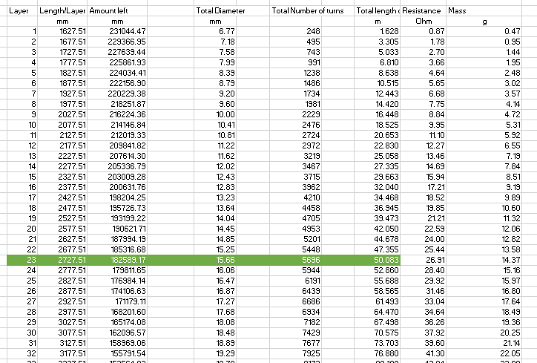

There maximum number of layers would be 25 to stay within the mass limitation. However, it was decided to go a little smaller to allow some room in the mass for the conformal coating and to allow for uncertainites/inaccuracies. So, it was decided to use 23 layers, which results in a total magnetorquer diameter of approximately 16 mm, a total mass of about 28.2 g, and a resistance of about 50 Ohms.

As the magnetorquer will be controlled from the custom board, it will be easy to add in a 100Ω resistor in series with the coil.

Finally, the resulting magnetic dipole moment was calculated.



The relative permeability, μ, was assumed to be 1000. This is because the effect of the permeability is logarithmic – it has a larger impact on the magnetic dipole moment the lower it is. The difference in 10 000 and 1000 is approximately 0.01. The actual relative permeability is likely higher than 1000, however it was thought it was better to lowball it, especially since the effect is minimal.

Nd was found to be 0.02965, which results in a magnetic dipole moment of approximately 0.493 A/m2. This was deemed to be more than adequate as the majority of off the shelf magnetorquers for cubesats have a magnetic dipole moment of 0.2 A/m2.

This means that there could be losses that we are not accounting for, or other factors that were not taken into consideration. However, even if the theoretical dipole moment that would be produced is halved, it is still more than most off the shelf components so it should be adequate.

### Final Design

The final design is summarized in the tables below:

Constraints:

|  |  |  |
| --- | --- | --- |
| Parameter | Value | Max/Min/Equals |
| Voltage | 5V | Equals |
| Power | 200mW | Max |
| Length | 50 mm | Max |
| Total Diameter | 20 mm | Max |
| Temperature range | -100’C to 120’C | Equals |
| Mass/magnetorquer | 30g | max |
| Wire insulation | Either PTFE or ETFE |  |

Permalloy 80 Properties:

|  |  |  |
| --- | --- | --- |
| Property | Value |  |
| Density | 8.72 g/cm3 |  |
| Relative permeability | Approx. 10000 | Varies. |
| Chemical Composition | 80% Ni, 5% Mo, 15% Fe |  |

Copper properties:

|  |  |  |
| --- | --- | --- |
| Property | Value |  |
| Density | 8.96 g/cm3 |  |
| Resistivity | 1.68 x 10-8 Ωm |  |
| Temperature coefficient | 0.004041 K-1 |  |

Selected parameters:

|  |  |  |
| --- | --- | --- |
| Parameter | Value |  |
| Core diameter | 6.37 mm |  |
| Number of turns/layers | 5696/23 | Results in 50 m of wire/coil |
| Wire gauge | AWG 32 |  |

Results:

|  |  |  |
| --- | --- | --- |
| Parameter | Value |  |
| Mass core | 13.81 g |  |
| Mass wire | 14.37 g |  |
| Total mass | 28.18 g |  |
| Resistance | 27 Ω | Add 100Ω resistor |
| Magnetic Dipole moment | 0.49 A/m2 |  |

## Next Steps

The next steps would be to build a magnetorquer according to the specifications above and test it to determine the actual dipole moment and/or torque that can be produced. This would have to be done in a faraday cage.

Additionally, a coil winder needs to be designed and built so that the torque rods can be produced.

## Magnetorquer Design References

|  |  |
| --- | --- |
| [1] | D. Miller, "Design Optimization of the CADRE Magnetorquers," University of Michigan, May 2, 2013. |
| [2] | M. Mehrjardi and M. Mirshams, "Design and Manufacturing of a Research Magnetic Torque Rod," *Contemporary Engineering Sciences,* vol. 3, no. 5, pp. 227-236, 2010. |
| [3] | M. Post and R. Lee, "Design of Attitude Control Ssytems for Cubesat - Class Nanosatellite," *Control Science and Engineering,* no. May, 2013. |
| [4] | A. Aydinlioglu, "Desgin Development and Production of Electromagentic Coils for Attitude Control of a Pico Satellite," Aachen, 2006. |
| [5] | D. Guerrant, "Design and Analysis of Fully Magnetic Control for Picosatellite Stabilization," California Polytechnic State University, 2005. |
| [6] | J. Li, M. Post, T. Wright and R. Lee, "Design of Attitude Control Systems for Cubesat-Class Nanosatellite," *Control Science and Engineering,* 2013. |

# Cubesat Structural Design

Acronyms:

* COM: Center of Mass

This summer, I reworked the structural design of the cubesat for a few reasons:

1. The magnetorquers were not near the center of mass of the cubesat, which is better for controlling the attitude of the cubesat.
2. The team did not allocate space for the engraving to be made by the Nunavut Artic Collage.
3. The team included thermal controls such as heat sinks and thermal straps, which are to be discarded as no other cubesat has implemented thermal controls, so they were deemed to be unnecessary.
4. The placement of the selected antenna (the Endurosat model) inhibits connecting wires from the ‘top’ of the cubesat to the ‘bottom’ of the cubesat. The Endurosat antenna is 98 mm x 98 mm, and the center of the antenna needs to be kept clear for antenna deployment, so there is limited room to run wires.
5. The components were not arranged in a way that the PC 104 stack could be used to reduce wiring.
6. Components, such as the ESP have changed
7. Deployment switches are required.
8. Remove before flight pin is required.

## Component Changes:

Some of the components to be used have changed.

|  |  |  |
| --- | --- | --- |
| Component | Changed to/from | Reasoning |
| Antenna | To Gomspace UHF antenna.  From Endurosat UHF antenna. | It would be very challenging to have the wires pass by the Endurosat antenna, as the antenna has no holes in it to allow wires to pass through, and the wires cannot pass on the side as the antenna needs to be able to deploy. The Gomspace antenna has a hole in the center of it that wires can be passed through.  The Gomspace antenna requires a different type of antenna deployment as it does not come with one. The antenna fold against the cubesat’s body, so the antenna needs to be near the ‘top’ of the cubesat. |
| Heat transfer system | Removed | No other cubesats have heat control methods. The capstone team included it as their supervisor said it was mandatory. |
| Solar Panels | Redesigned to custom made solar panels. | Matt Cross thinks it will be cool to have built our own. I agree. This also allows us to develop the deployment system for the Gomspace antenna and the remove before flight pin. |
| Magnetorquers | Replaced with homemade ones. | It was decided to replace the off the shelf ones for ones that we designed and fabricated ourselves, since this should be within our ability, and then more students can have the opportunity to build something that is going to fly in space. |
| Sun sensors | Removed. | Kind of replaced with photoresistors/ detectors, not sure yet and trying to get the solar panels to act as sun sensors.  This decision was made because the sun sensors are really expensive. |
| Order of things in the stack. | Redone. | They had the OBC adjacent to a camera, and everything else above it. Especially the ESP. Which makes more sense for the COM, as the COM needs to be at the geometric center, and keeping the heavier component closer to the center is better. However, all the Endurosat components that are going to be used (ESP, OBC, transceiver) are all connectable with a PC104 stack. This would GREATLY reduce the amount of wiring required, as the components could just slot into one another. It would also work for the custom board to have a PC 104 connector to take care of the majority of the wiring. Unfortunately, the ESP board only has the connector on one side, so it has to be at the bottom of the stack. |
| GPS & GPS Patch antenna | Added | It was added so that the attitude control could be more accurate and for another reason that I don’t remember right now. |
| ESP | ESP 1 removed  ESP 2 added | The ESP 2 comes with 2 built in batteries as opposed to 1, extending the battery life and removing the need for an external battery. |

## Summary of mechanical constraints from Nanoracks.

See Appendix I. Still read the deployment interface document.

Size limitations:

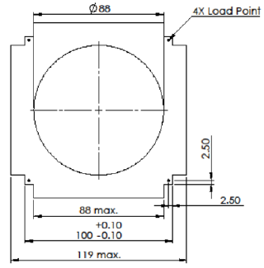

Max length: 227 mm

Max mass: 3.60 kg

There must be deployment switches that are plunger type on the -z faces of the rails or of the roller/lever type embedded in the rails.

The RBF pin (remove before flight) must be accessible from the +y face of the deployer.

## Things to take into consideration

The primary concerns are the constraints provided by nanoracks, which are outlined above.

It is also important to design for assembly, design for manufacturing, and take into account the mechanical/electrical interface.

There must be adequate room for wires, and the bend radii of the wires must be accommodated for. For example, the coaxial cables for the transceiver to the antenna have a minimum bend radius of 15 mm.

As there are no moving parts after the antenna is deployed, there are not strict zones that mechanical or electrical cannot interfere with.

Bolt/nut access for assembly.

#### Rails

First, I designed the rails for the cubesat. I mimicked the Endurosat design by having a thin (2mm) L bracket at each of the corners. The legs of the L bracket are each 15 mm, as the plates to mount the components need to be mounted to the rails and there cannot be anything in the 6 mm closest to the corner, as this is where the Nanoracks deployer interfaces with the cubesat. The rail design was slightly iterative as the other parts came together. The width, length, and hole placements were revised. The final length was 211 mm, allowing for 8 mm of height on the top and bottom cover plates. Other modifications included cut outs for the Gomspace antenna, as it was too wide to fit between the rails. The final rail is shown in the picture below. Each rail is very similar, yet they are all unique. They are not quite left/rights of each other, as the antenna is not symmetric.

#### Cover plates

Figure 1: Rail

The top and bottom cover plates became separate parts to attempt to minimize the manufacturing costs of the rails. This also follows the Endurosat model of having the top and bottom faces separate and bolting them to the rails.

The design of the top and bottom cover plates was simple enough – have a face at the top of each rail as per Nanoracks specifications. This face extends from the main plate a few millimeters so that the camera lens can poke out of the cover plate slightly so that there will be a better image. There is a limitation from Nanoracks that the ends of the rails must be at least 2 mm from the ‘highest’ point on the cubesat, so that set the height of the camera.

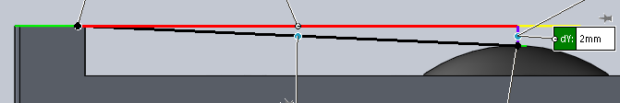

Figure 2: Relation between rail ends and top of camera lens. There must be at least 2 mm, as specified by Nanoracks.

The cover plates have a small hole for a photosensor, and the bottom cover plate has a hole for the GPS patch antenna and the deployment switches in the rails, as seen below. As of right now, (last update July 16th, 2019), the patch antenna hole is not finalized, we are waiting on the company to reply to us with more information. The camera hole was centered and the photosensor hole location was arbitrary. The tabs underneath are to attach the cover plate to the rails. The positions of these were determined by the UHF antenna.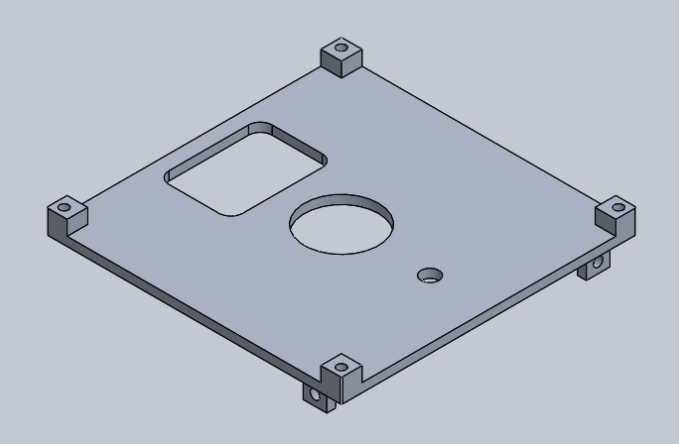

Figure 3: Bottom cover plate.

#### Stack

The Gomspace antenna that was selected has a hole in the center so that it can sit around the camera. It must be near the top, as it has a coaxial cable that has a bend radius of 15 mm, which needs room. There is room for this around the lens of the camera. Also, because the antenna itself does not bend, it needs enough room to fold down along the body.

The next couple pictures illustrate the camera, cover plate, and antenna relations. The antenna is shown in both the deployed and stowed position simultaneously.

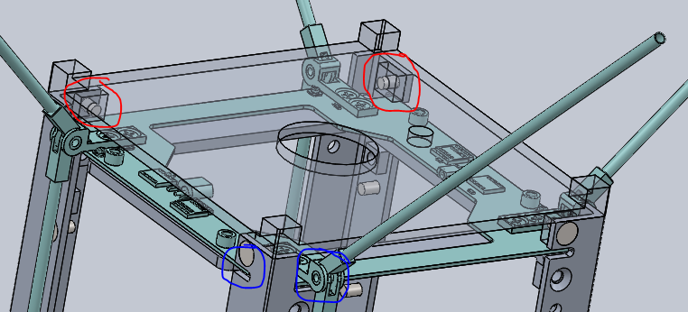

Figure 4: Antenna, rails and cover plate relation. The cover plate is transparent. The blue circles show where the antenna slots into the rails. The red circles show that the tabs that hold the cover plate onto the rails are on the opposite side of the corners from the antenna itself.

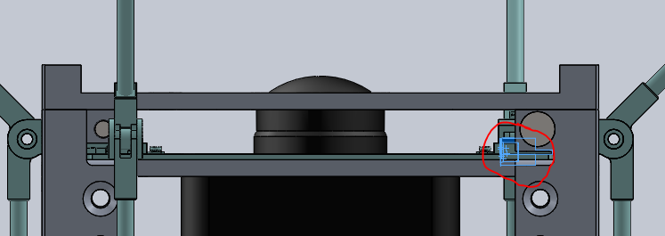

Figure 5: Relation between the camera and the antenna. The antenna has a coaxial cable that plugs in where the red circle is. If the antenna is any lower, than the coaxial cable would stick out into the wider part of the camera and there would not be enough room for it’s bend radius. On the flip side, if it was any higher, that I do not believe there would be enough material for the bolt to hold the cover plate to the rails. So that set the height of the antenna.

At this point, the heights of the camera and the antenna are set at the +z side of the cubesat.

Symmetrically, the height of the camera at the -z side of the cubesat is set too. The patch antenna for the GPS was decided to be on the opposite face of the UHF antenna, as the UHF antenna needs to point to the ground, where the GPS satellites are going to be orbiting above the cubesat. This will reduce the need for changing the CubeSat’s orientation.

To save space, it was decided to have the ESP (which has to be at the bottom of the stack) to share a mounting plate with the bottom camera to save space and material. This set the location of the ESP.

Then, the rest of the components were set off the height of PC 104 connectors. After the ESP, it was determined to have the two custom boards so that the magnetorquers could be as close to the center of the cubesat as possible. Both custom boards have mounting holes in the same locations as the mounting holes on the UHF transceiver, ESP, and OBC. If wanted, rods could be passed through the majority of the cubesat to hold the components. It could add structural support as well, however I believe the mounting plates are more beneficial structurally.

On the bottom custom board is the GPS transceiver, and the z magnetorquer. There are also some picoblade 12 connectors to connect to the OBC, as this is how the magnetorquer will be controlled. There is some additional space that could be used to attach the temperature sensors, photosensors, or other components as needed.

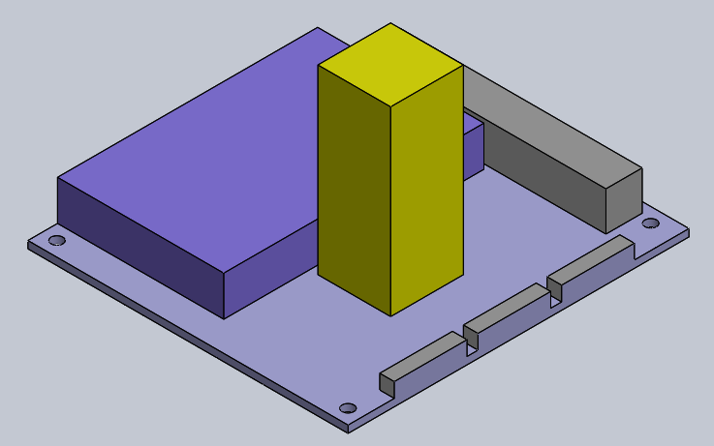

Figure 6: Custom Board 2 (the 'bottom' one). The magnetorquer is yellow. The GPS transceiver is darker purple. the board is light purple. The connectors are grey.

The top custom board holds the other two magnetorquers, the gyroscope and more connectors. This board is at 117.6 mm (assuming the magnetorquers are 15 mm in diameter), which is pretty close to the center axis of 113.5 mm. It is a little high, however, it is as low as it can be. And the COM is not determined yet, and that is the more important one. If the COM is shifted slightly up from center, it could be very close to the center of the magnetorquers.

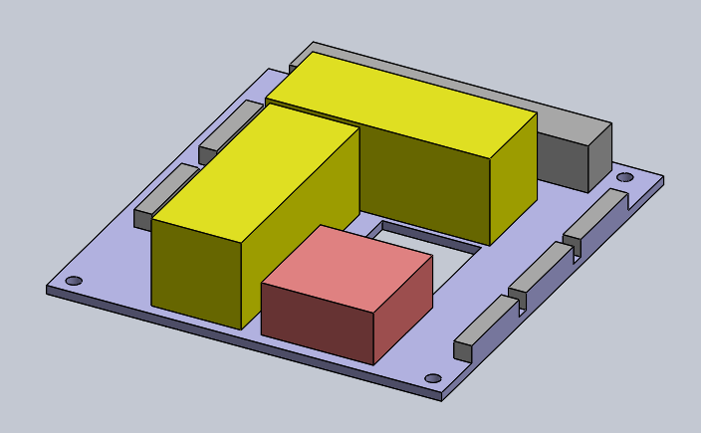

Figure 7: Custom board 1. Magnetorquers are yellow. Connectors grey. Gyroscope block is red.

When designing the rough layout of the boards, the primary concern was to have the magnetorquers all pass as close to the center of mass as possible. Obviously, this is not physically possible, as the magnetorquers cannot be in the same space, but they were put as close as possible. Also, I placed the Pico blade 12 connectors on the same side as the ones on the OBC to try to minimize the wiring.

The parts that still need to go in the stack are the engraving, the transceiver, and the OBC. I thought to put the transceiver at the top, so that it is closest to the antenna. It cannot share a mounting plate with the camera, as the PC104 stack on the transceiver would interfere. Also, as the bottom of the PC104 stack is already fixed to the bottom camera plate with the ESP, it would not be good to fix the top as well, in case it is not an exact number of PC104 connectors apart.

Additionally, I thought the transceiver should go above the OBC because it is heavier than the OBC and the mass of the ESP needs to be balanced so that the COM is near the geometrical center of the cubesat. Also, the OBC should be more central so there’s less wiring.

I thought to have the OBC adjacent to the transciver, then have the engraving, though the order of these probably doesn’t matter. I just kind of arbitrarily chose it. How it is now though, the z magnetorquers can be fixed to the bottom of the engraving plate, so that a separate z magnetorquer support is not required. If the OBC was there, I believe an additional support for the z magnetorquer would be required.

The resulting stack is shown below, where, from top to bottom:

* Black = camera
* Turquoise = antenna
* Light blue = transceiver
* Pink = OBC
* Tan = gold engraving
* Yellow = magnetorquers
* Red = gyroscope
* Light purple = custom board
* Purple = GPS transciver
* Green = ESP

The GPS antenna is not in the model.

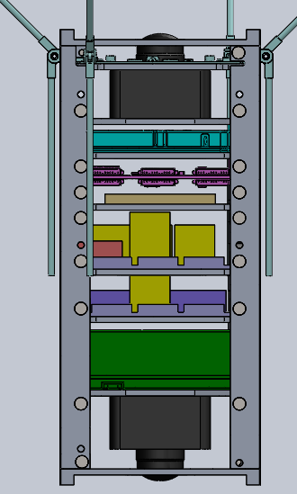

Figure 8: Cubesat Stack

From the side, the PC104 stack is visible.

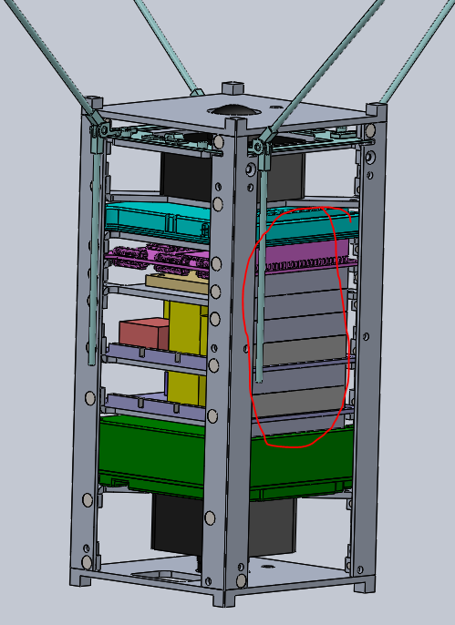

Figure 9: PC104 stack. Circled in red.

The next step was to design the mounting plates for all the components. where possible, I kept the mounting holes in the same locations. I removed what I considered ‘extra’ material, to conserve mass. I tried to keep them symmetric so that the COM would remain in the center.

I followed the capstone team’s design of having plates laser cut, then bending the corners like sheet metal to mount them to the rails. The OBC’s mounting plate is more mounting supports as the connectors on the OBC prevent a plate going along then entire board. The plates are the same, where possible, to reduce manufacturing costs. The directions for the tabs to be bent in was determined by space to bend them. Some plates are the same except for the direction the tabs get bent in, for example the camera plates.

The plates are 3.175 mm thick, as 2 mm seemed too thin, and the company from which we could get them has imperial measurements and the closest to 3 mm is 1/8th.

The plates are shown below:

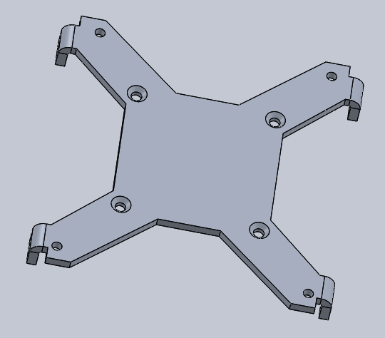

Figure 10: Bottom Camera and ESP Plate

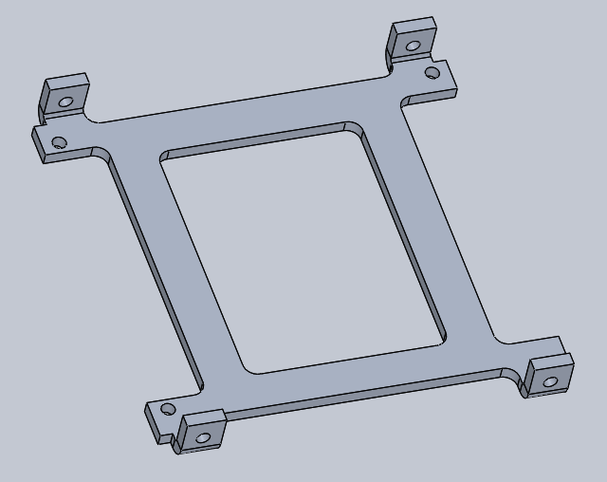

Figure 11: Custom Board Plate

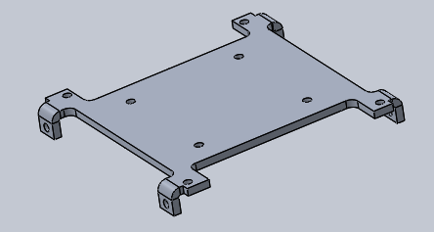

Figure 12: Engraving Plate

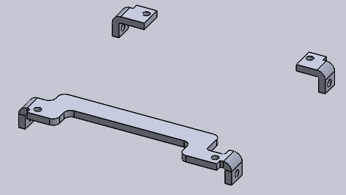

Figure 13: OBC Supports

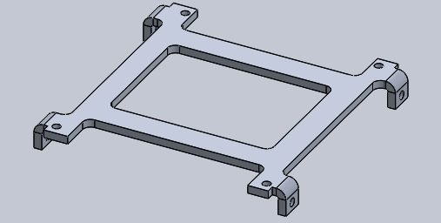

Figure 14: Transceiver plate. Same as custom board but tabs bent in other direction.

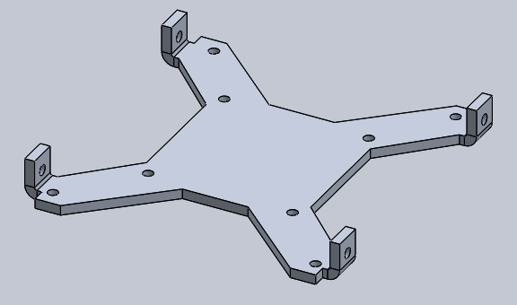

Figure 15: Top camera plate. Same as bottom except camera mounting holes are not countersunk and the tabs are bend the other way.

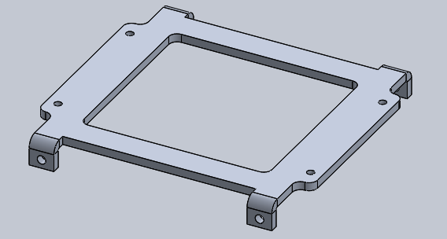

Figure 16: Antenna Plate

The plates are all going to be mounted to the rails with M3 countersunk screws (the rails are countersunk; this is to allow the solar panels to be mounted on top). Heli coils will be used (as per the CSA’s recommendations) to help lock the bolts in place and to help distribute the load across the threads. The components will be mounted to the plates probably with button head M3 bolts. If possible, a locking nut will also be used. The holes in the plates to mount them to the rails will be threaded.

For the solar panels, the design is still being worked on, as the requirements for the solar panels themselves, the RBF pin, the antenna deployment and the photosensors are being worked out. But holes have be made to mount the plates and a base plate has been designed, if needed. These plates will be mounted with button head bolts. The corresponding holes in the rails will be threaded with helicoils.

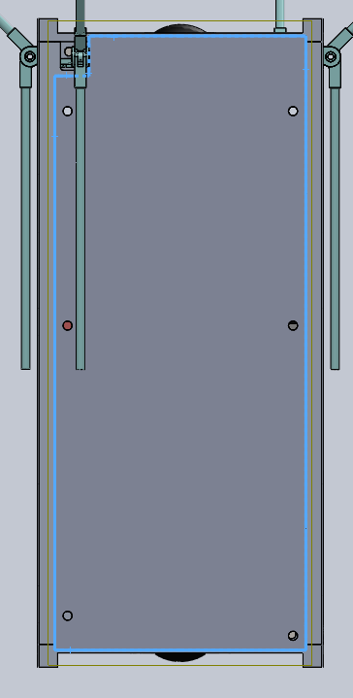

Figure 17: Solar Panel Plate

## Gold Engraving

The Nunavut Artic College will be creating a gold engraving to fly in the satellite. I tried to allocate as much space for it as could fit. It is shown in the model below, and sits between the custom board and the OBC.

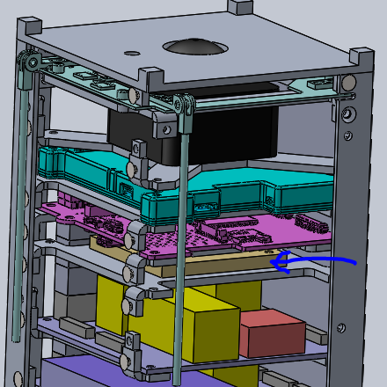

The space currently allocated for the engraving is 55 mm x 55 mm x 5 mm – this is what is used for the mass budget assuming the engraving is made of pure gold.

The maximum size the engraving could be is: 60 mm x 70 mm x 5 mm.

The minimum size would be 7 mm x 7 mm x 0.5 mm, I guess. This would only require one bolt. So that bolt would have to be really secure to ensure that the engraving does not go floating through the cubesat during flight. Ideally, the minimum would probably be 7 mm x 14 mm x 0.5 mm so that you could have 2 bolts. I’m just guessing at the minimum thickness. Probably would want it to be thicker than that so that it’s stiffer for the vibrations during launch, but I really don’t know much about how thick it would/should be. 2-4 mm would probably be better.

The interface with the engraving plate is going to be M3 button head bolts – the length of which will be determined after the height of the engraving is confirmed. Ideally 4 of them, one in each corner. Below is the hole pattern I currently have. This is not dependant on anything else, so it is easy to change.

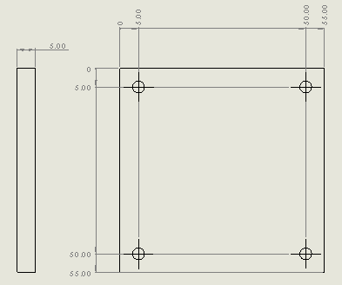

Figure 18: Engraving plate

## Manufacturing

|  |  |  |
| --- | --- | --- |
| Component | Manufacturing Method | Reasoning |
| Mounting Plates | Laser cut, then sheet metal bending | It is easier and quicker to laser cut the thin material as opposed to milling it. Laser cutting is cheaper and more accurate than water jet cutting. |
| Rails | Milling | The mounting holes for the plates must be in specific locations and the outer bend radius is specified by nanoracks. It will be expensive, but I don’t know how else to achieve the bend radius of 0.5 mm. Stock material has a larger bend radius. |
| Cover plates | Milling | They cannot be laser cut due to the different depths. They should not be hard to mill, just some what time consuming. This will also probably be somewhat expensive, but I cannot think of a better way to do it…. Maybe 3D printing.. not sure how expensive that is or if that’s allowed for space. Also seems slightly iffy if the entire load from the deployer will be on the rail ends. |
| Solar panel plates | Laser cut | For now… the design is not complete. |

## Assembly

First, to assemble the cubesat, all the components need to be ready to be assembled.

Ensure all parts are present:

* Bolts
  + M3 flatheads; 6mm x
  + M3 button heads
* Nuts
  + M3
  + 12 square M3
* Structural components
  + Rails
  + Mounting plates
* Electrical components
  + ESP
  + OBC
  + Camera x2
  + Completed custom circuit boards
  + Sensors
    - Temperature/photo
  + Solar panels

This list is not all-inclusive as the final components have not all been determined. But basically, ensure you have all components prior to starting to assemble the CubeSat.

Ensure that the custom boards and solar panels are already assembled and soldered. I am not sure right now what this will all entail, so I am not going to write detailed instructions on it. They are still being designed.

For Reference: I will be talking about the axis used in the solid works assembly model (Cube, in case you want to refer to it while assembling. So, in the picture below, it is the top view. The +y face is showing, the +x is on the right, -x on the left, +z on bottom, and -z on the top.

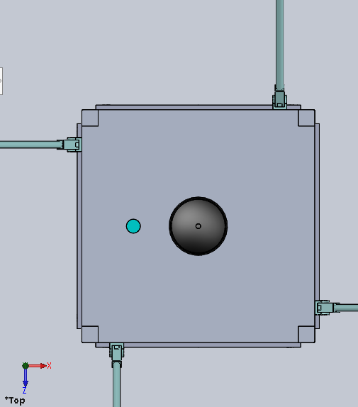

The following would be my recommendations on the order of assembly, based what I think would be easiest.

FOR ALL STEPS – WHEN INSERTING ANY BOLTS, USE THE EPOXY TO HELP HOLD THE BOLTS IN PLACE

1. Insert all helicoils. These will be inserted into:
   1. Holes on the rails for mounting the solar panels
   2. Holes on the plates for mounting them to the rails
2. Glue the square nuts onto the rails
   1. There are important because there will be solar panels that are put on at the end, and you will not have access to the inside to tighten the nuts.
   2. These go on the holes for the solar panels on the side of the rails with the mounting holes for the other plates. See picture. Not sure that made sense.. But it is so that the square nuts can butt up against the mounting plate tabs so they will not spin even if the glue breaks.

1. Mount all components to their mounting plates.
   1. For the -y camera, ensure that it is mounted before the ESP, as the esp will cover the holes to mount the camera
   2. It is better practice to hold the bolt head still, and tighten the nut, as this puts less stress on the threads of the bolts.
   3. Mount the photo sensors to the top and bottom cover plates
   4. Mount the GPS antenna patch to the bottom cover plate
   5. 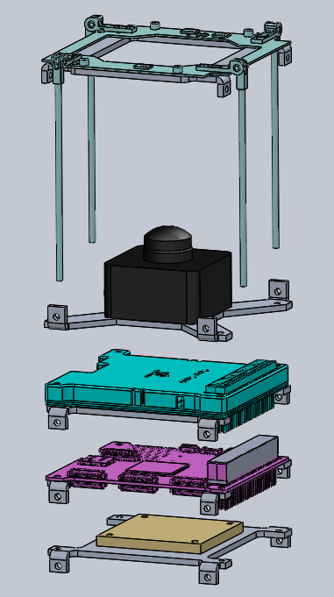 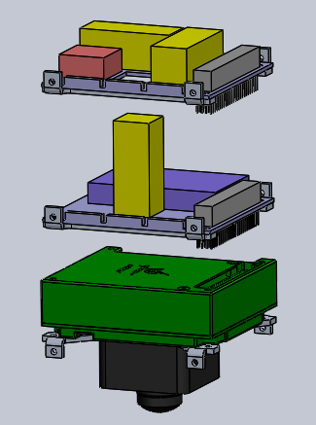

1. One layer at a time, mount the plates to the rails. This order is based on what I would think would give easiest access to the most nuts. With this order, the tabs will be accessible for 5/8 of the plates as you are moutning them, allowing the nuts to somewhat easily be tightened. I flipped the cubesat ‘up side down’ for this process as this is how I imagine it would be easiest, as you will have to ‘slide’ the components down into place. 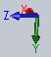
   1. Antenna
      1. 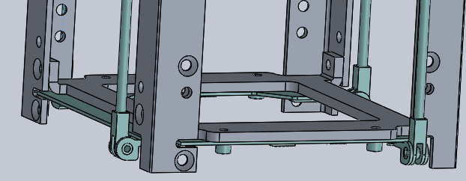
   2. Top cover plate
      1. Ensure the wires for the photo sensor are passed through the hole in the antenna.
      2. 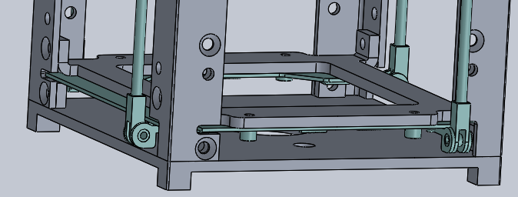
   3. Glue the first set of square nuts to the rails for the solar panels.
      1. 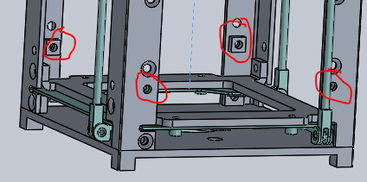
   4. Camera 1
      1. Attach the wire to the camera first.
      2. 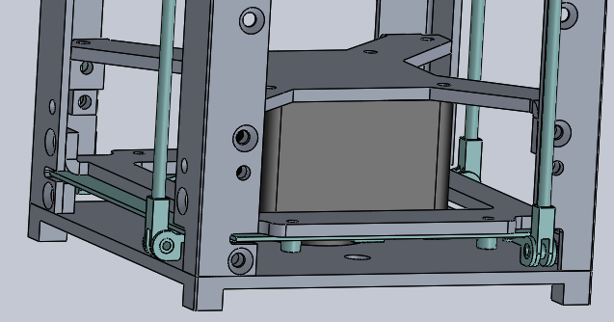
   5. Transiver
      1. Attach the coaxial cable to the transceiver
      2. Pass it down along the camera as you slide the transceiver along the rails
      3. Ensure that the cable from the camera gets passed up along the transceiver so it can get plugged into the OBC in the next step.
      4. 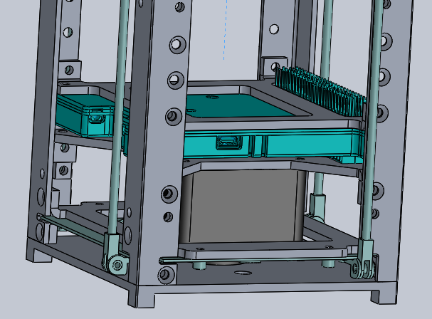
   6. OBC
      1. Attach the camera and the photosensor cables.
      2. Don’t worry about the picoblade 12 connectors to the custom board yet, but attach any other cables that you can.
      3. ensure that cables are not being pinched and that their bend radii are being met. Harness where possible.
      4. Use caution when connecting the PC 104 connectors.
      5. 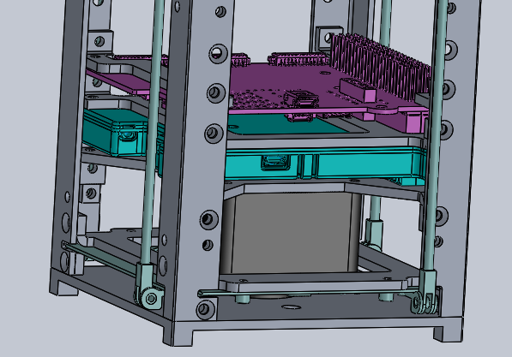
   7. Engraving
      1. 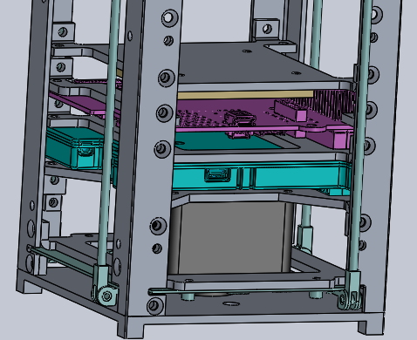
   8. Glue the next set of square nuts onto the rails and add 3 PC 104 connectors to the OBC
      1. 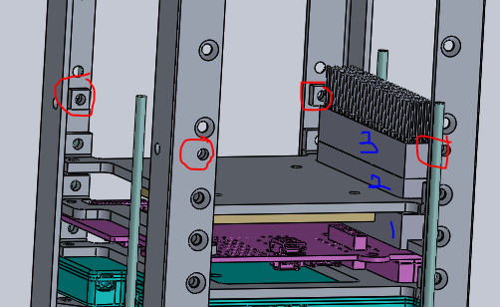
   9. Add epoxy (not sure which at this point – July 18, 2019) to the bottom of the engraving plate to prep it to hold the other end of the z magnetorquer.
      1. 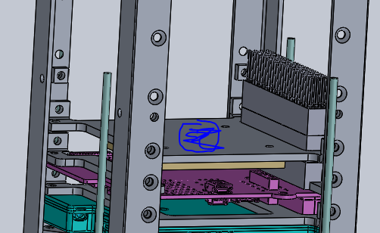
   10. Add custom board 1
       1. Apart from the picoblade connectors to the OBC, connect any wires needed. Not sure what this will include.
       2. 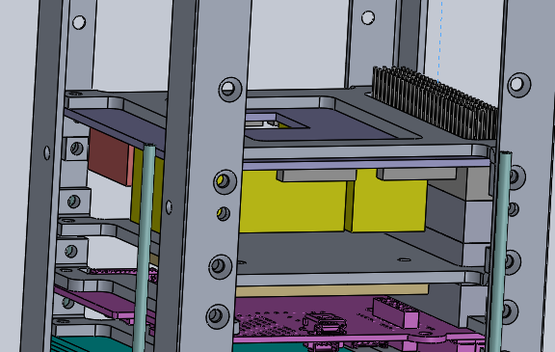
   11. Add a PC 104 connector on custom board 1
   12. Add custom board 2
       1. Ensure that it is secured to the bottom of the engraving plate
       2. 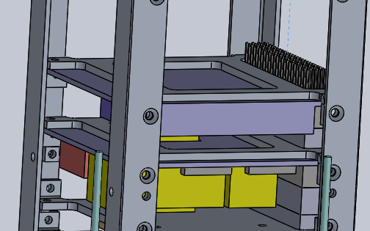
   13. add a PC 104 connector
   14. add the ESP and bottom camera plate
       1. 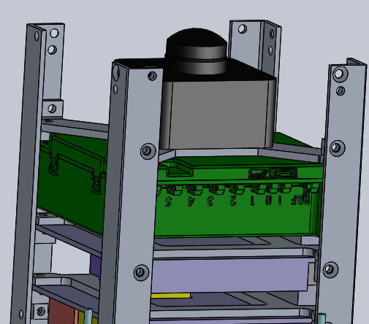
   15. Glue the last set of square nuts onto the rails
       1. 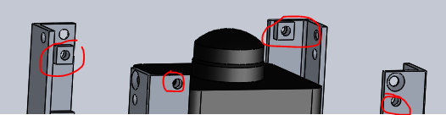
   16. Add the bottom cover plate
       1. Ensure the gps antenna and the photosensor are attached first and that their wires are going towards the OBC/custom boards
       2. Ensure the deployment plungers are in place prior to mounting the plate.
       3. 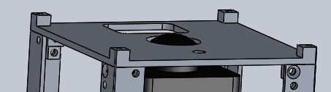
2. Attach the deployment switches
   1. I don’t have details on this yet… may need to do this before mounting the bottom cover plate.. not sure yet.
3. Attach all the wires in the stack.
   1. Picoblade connectors from OBC to custom boards
   2. Camera to OBC/custom board
   3. Antenna to transceiver
   4. Gps antenna to gps transceiver
   5. Solar panels to ESP (and OBC??
4. Perform all harnessing possible.
   1. Use wires and staking
   2. I recommend putting some staking along the PC104 connectors to ensure they do not come apart during launch.
5. Mount the solar panels that do not require the square knots
   * 1. 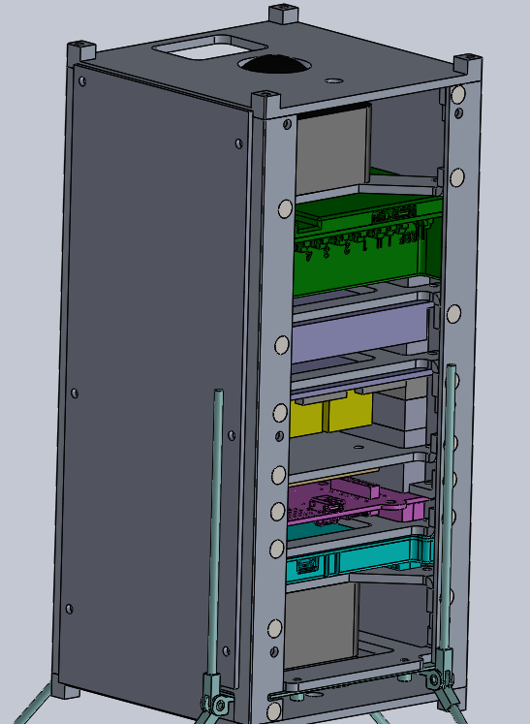
6. Mount the solar panels that require the square nuts
7. Restrain the antenna into the deployment system.
   1. 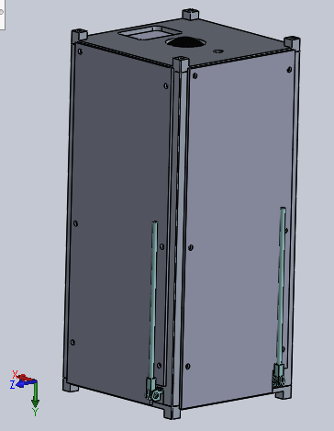
   2. Please note that the antenna shown is the length of the antenna for a 1u system… the actual one will be longer.. this is the cad they sent me.

## Bill of Material (BOM)

I created a BOM, both for budgeting cost (with potential suppliers) and for mass and quantity. Please see below. It has been being updated on a rolling basis. It is by no means complete. My thought was to have one document with everything that could possibly be needed to have a total cost, with all suppliers in one place. Then, as I was doing the structural design, I thought to compile the mass budget as well as other information that was useful for designing the structure.

Please refer to the actual excel document.

### Budget/Suppliers



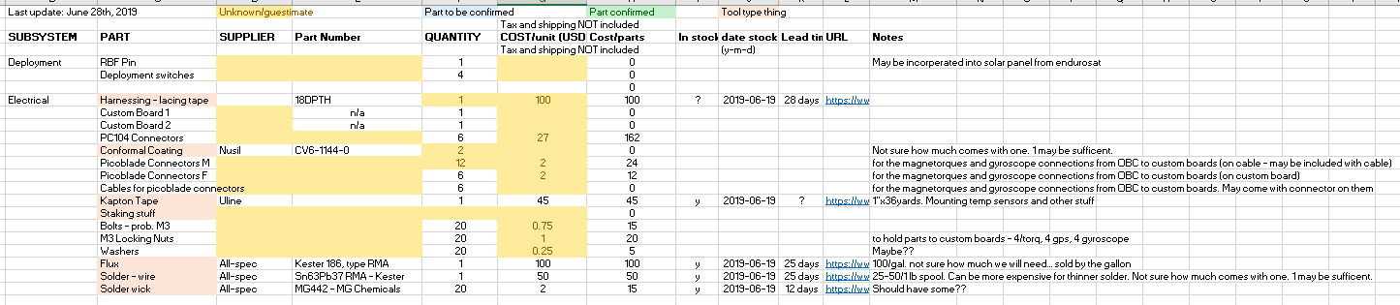 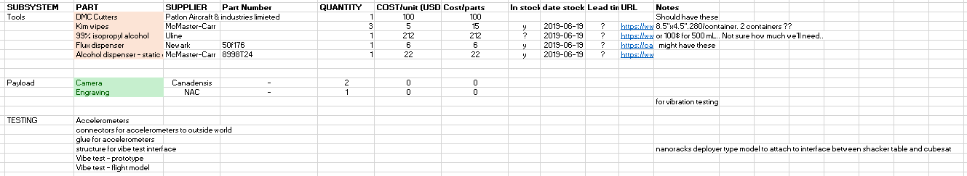 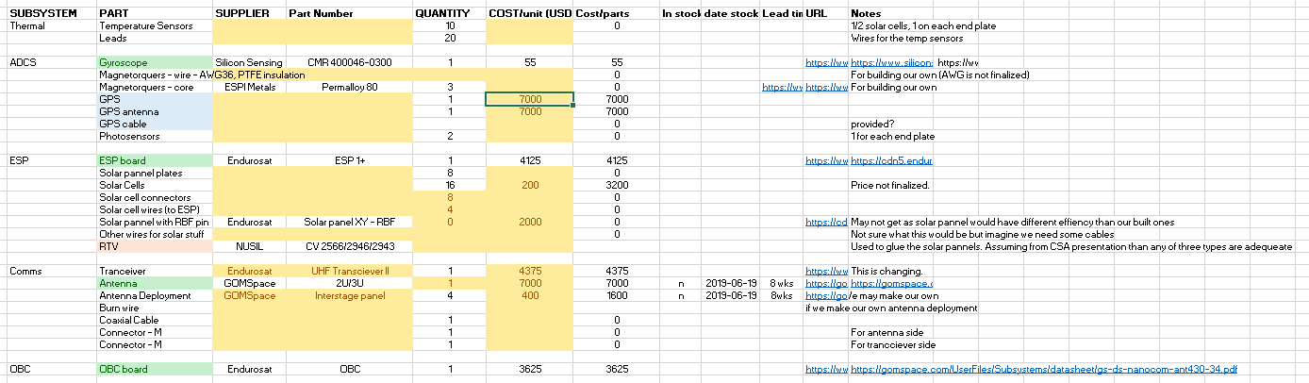

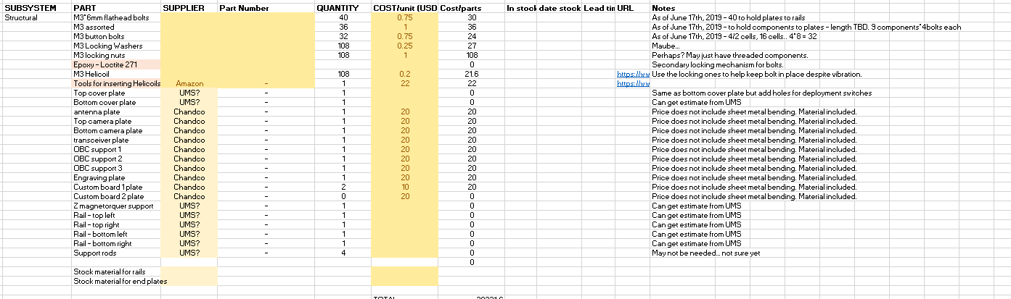 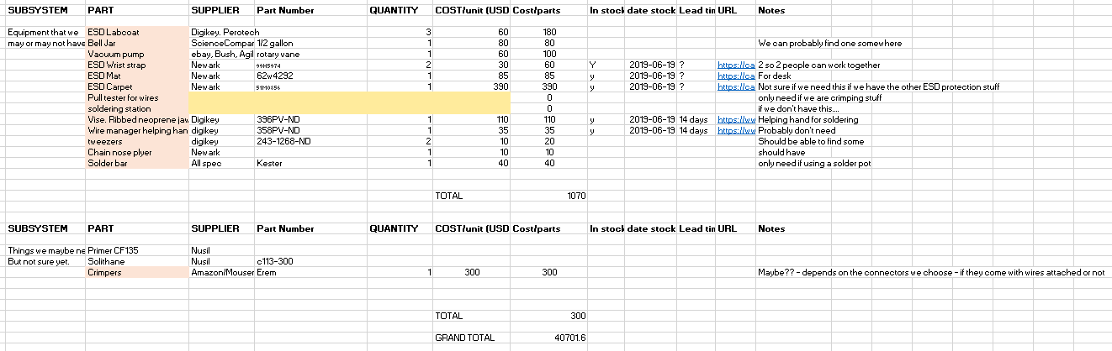

## Mass Budget & Assembly Properties

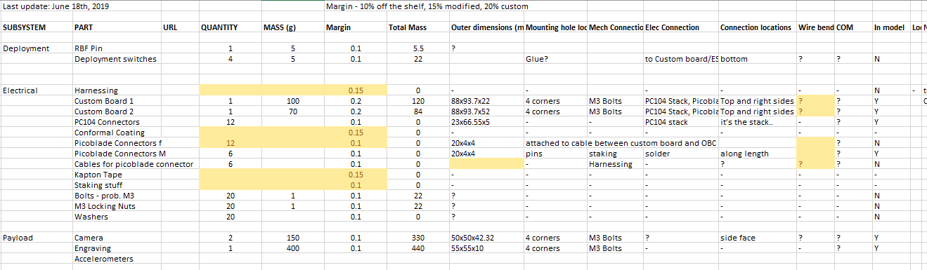 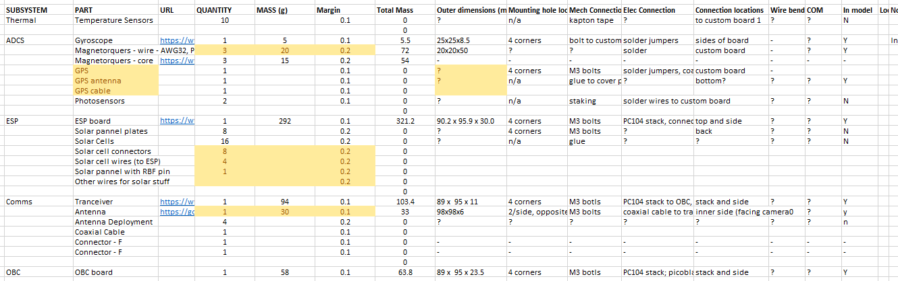

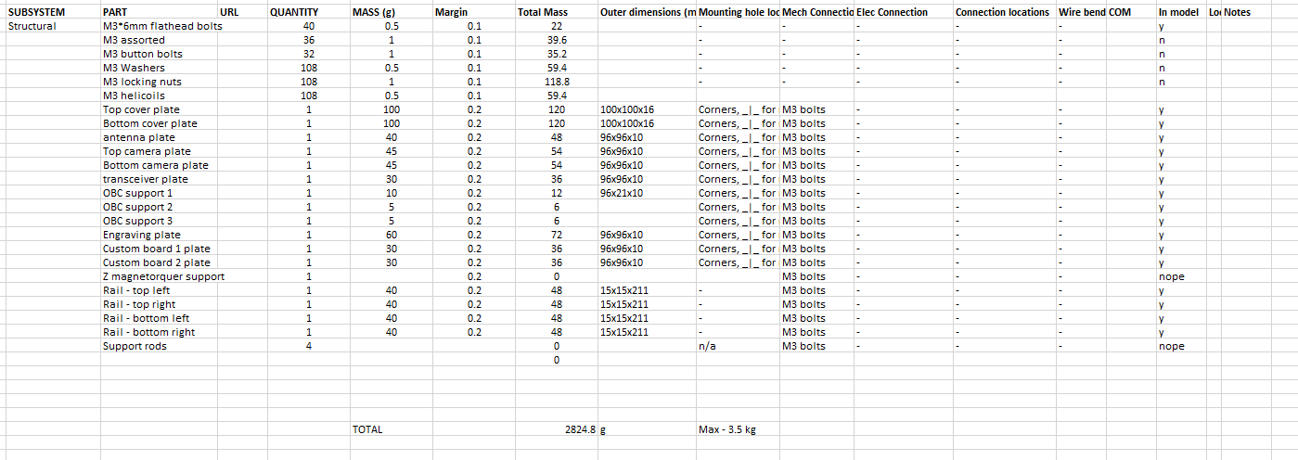

## FEA

Solidwork’s FEA was performed on the model to help test if the structure could withstand the loading during launch.

Please refer to Appendix III for the complete compilation of images taken during the FEA process.

First, the model was simplified:

* Replaced the step file components with dummy masses. The masses are fairly close to the mass of the component it is replacing.
  + The step files did not have all parts and the mass distribution was odd
  + The step files had parts with lots of details that would have unnecessarily complicated the mesh
  + ESP, OBC, antenna (didn’t actually mock up the antenna… it’s only 30 g
* Removed the PC 104 stack
  + All the little pins would have really complicated the mesh.
* There are no bolts to hold the components to the stack…
* Removed the bolts – they would complicate the mesh and make the process take longer.
* Replaced the cameras with dummy masses

**Materials:**

* All structural components were assigned AL 6061-T6, as AL 6061 is the material recommended for the structure, and the capstone team used the t6 finish.
* The component materials were selected such that the mass was approximately the actual component mass for the given volume it is supposed to take up (mostly for the center of mass of the structure).
* The materials are as follows:
* AL 6061 T6: Antenna plate, camera plate top, camera plate bottom, cover plate top, cover plate bottom, custom board plates (3), rails (4)
* Zoltek Panex: Cameras (2)
* PTB General Purpose: Custom board 1, custom board 2, fake OBC, fake transciver
* Gold: Engraving
* 1060 Alloy: Fake ESP

**Other options:**

* Soft springs were utilized as this could be considered to be the deployment container – motion in any direction is limited. Though the force from the soft springs would be significantly less than from the deployment device. Also the capstone team used it.

**Mesh**

* Mesh controls were applied to the fillets on the rails and on the inner bend radii of the plates with element sizes of 0.15 and 0.2 mm, respectively, so that there should be at least 3 elements over the bend radius.
* The curvature based mesh option was selected as this is supposed to help map the element size to the feature size (<https://hawkridgesys.com/blog/solidworks-simulation-curvature-based-vs-standard-mesher>). For the curvature based mesh, the maximum element size was set to 5mm (for the fake parts), the minimum element size was set to 0.5 mm (to get 4 elements across 2 mm), the minimum number of elements in a circle was 8 (the default), and the size change ratio was 1.6 (also default).
* The entire cubesat could not be meshed (it kept crashing), so using symmetry, only a quarter of the cubesat was used.

### Static Simulation

The first simulation was the static acceleration loads. These are 7g in x, and 4 g in y and z, as per the nanoracks document (with the nanoracks frame of reference, not the solidworks frame of reference). This resulted in the loading and fixtures shown below:

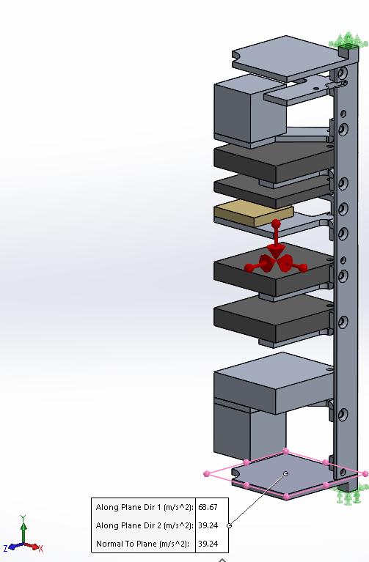

Figure 19: Loads and fixtures for the static simulation

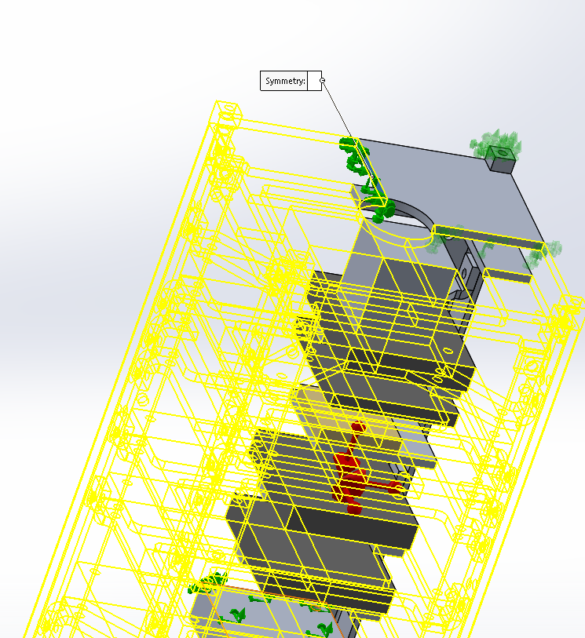

Figure 20: With symmetry

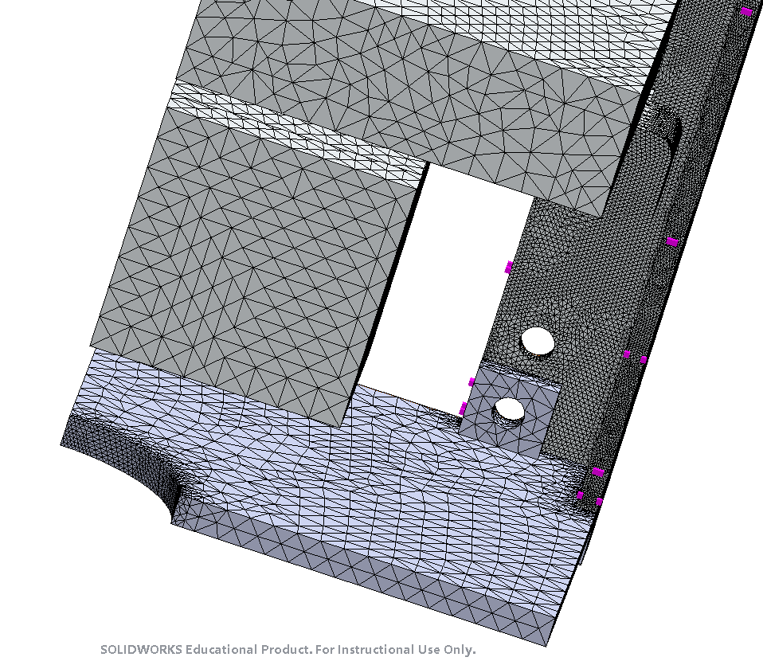

Figure 21: Meshed

For the results, I looked at the Von Mises stressed – because it is a ductile material. If the von mises stress is greater than the yield strength, the parts will plastically deform.

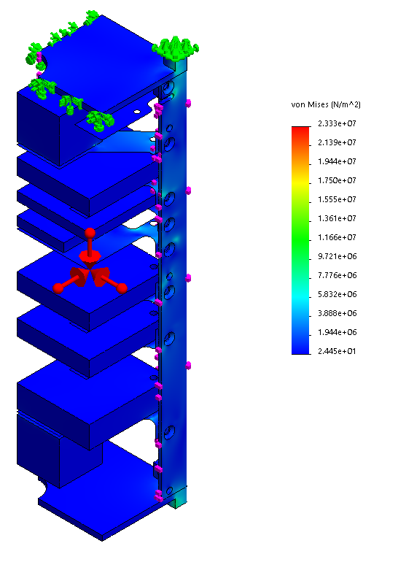

Figure 22: Results - Von Mises stresses

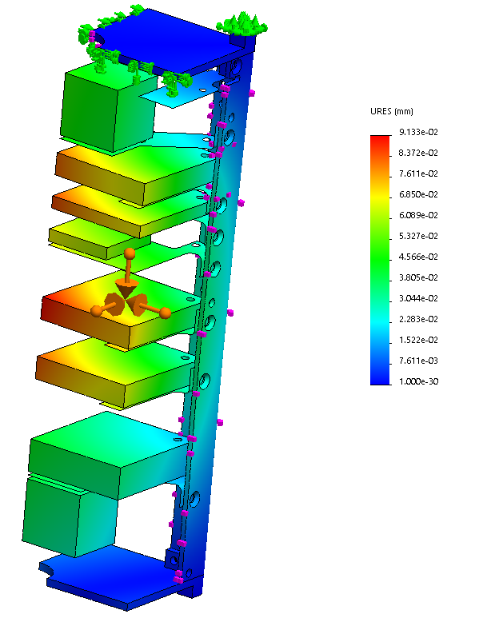

Figure 23: Results – Displacement

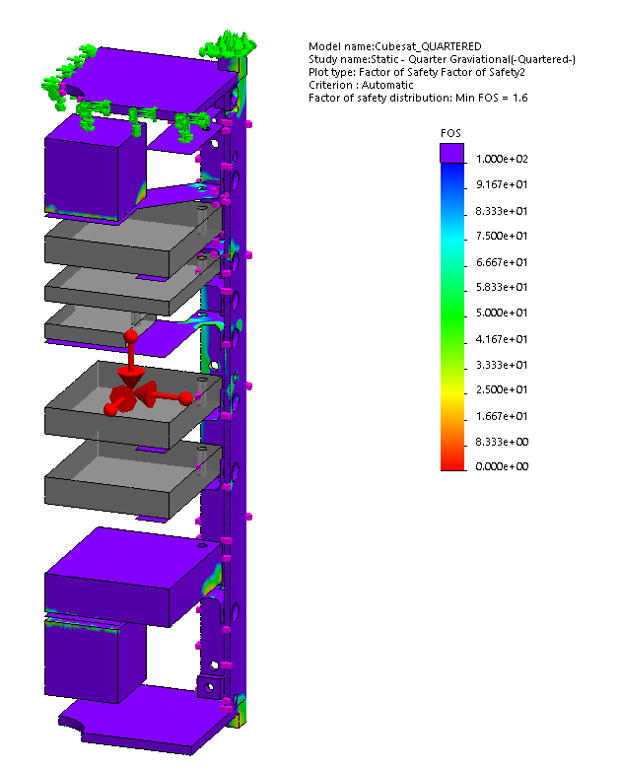

Figure 24: Results - FOS. Grey are materials that are not AL6061.

The minimum FOS was 1.6. This is a little low, but it was on the camera, not on the structural plate, and the camera was modeled for the mass, not the structure, this was deemed to be acceptable. As you can see, most of the structure has a FOS above 100 (purple).

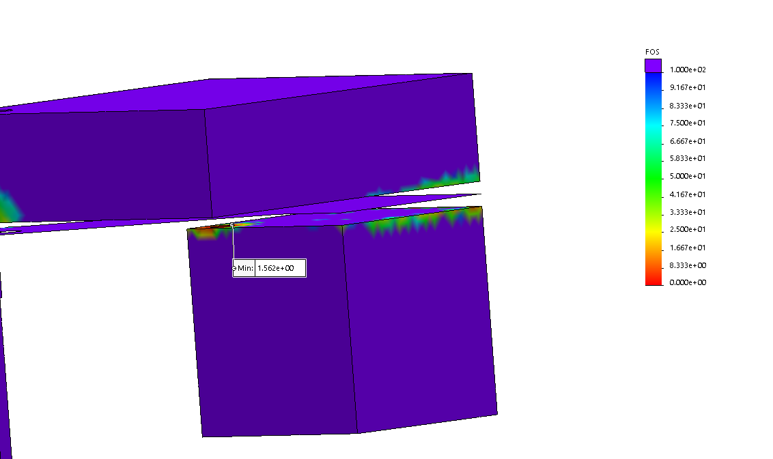

Figure 25: Min FOS at bottom camera

The stress at the bolt hole locations was also checks to ensure that bolts could be selected that should match the stress there.

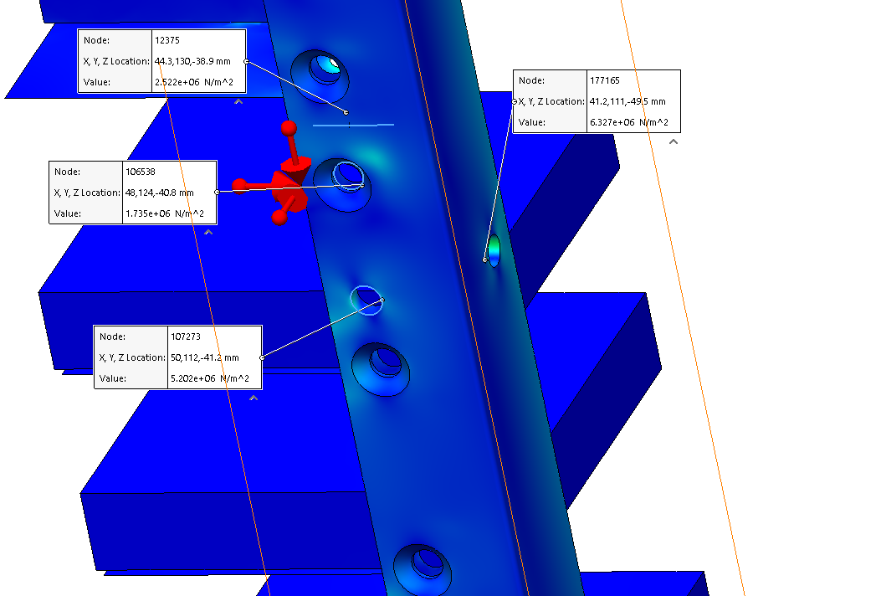

Figure 26: Bolt hole von mises stress

The simulation was also performed with the gravitational accelerations in the opposite direcitons, and the results were extremely similar. Again, the lowest FOS was acceptable – 1.734 – and it occurred in the same location – on the bottom camera. The photos of the results are also in Appendix III.

### Modal Analysis

This type of study allows the natural frequencies of the object to be determined.

However, I do not have much knowledge about it, so I would take these results with a grain of salt. Also, due to the simplifications I made to get the model to mesh, the fundamental frequency would be affected. For example, having the bolts in place would affect the fundamental frequency as they add mass.

Anyways, for the model I had, the first 4 fundamental frequencies are: 113.5 Hz, 155.13 Hz, 167.57 Hz, and 197.04 Hz. These seem very close together, but that seems to be because the difference between them are which plates are vibrating.

Please refer to Appendix IV for images from the results of this study.

# Conclusion

Overall, it was an iterative process to determine how to figure out a means of having everything fit together. This is by no means the only way or the best way but is a design that I believe would work.

# Next Steps

Mechanically, a prototype should be built and tested. This will allow the assembly sequence to be verified, and the structure can be vibration tested with dummy masses to verify the structural integrity of the design. The results of the vibration testing will also allow confirmation of the FEA performed.

For this, see the section on the vibration testing with regards to the mass simulation. The appropriate masses need to be determined to test the structure to ensure it will not fail before the cubesat is tested with the actual electronics on it.

The deployment switch interface still needs to be investigated and developed. There are the slots in the bottom cover plate for the plungers of the switches. These could be the actual switches or just plungers that then push on another switch. If the latter a means of attaching and aligning the switches needs to be determined.

A PC104 connector needs to be obtained and the height of it needs to be verified **to confirm the heights of the holes in the rails.**

After the solar panel design is complete, a detailed model needs to be done. The masses of all components need to be confirmed, and the COMs of the off-the-shelf components need to be obtained. The square nuts need to be replaced with custom built rectangle nuts, so that the height of the hole can be at a height that works for the solar panels.

Then the COM of the overall cubesat can be calculated.

The antenna deployment and RBF pin need to be investigated. They are going to be incorporated into the solar panels.

If desired, more detailed FEA could be performed with a more detailed mesh.

The quote from UMS for the rails and the top and bottom cover plate still need to be obtained. I was also going to talk to Chris Vandelaar and see if he had any suggestions for the design to make it easier to machine.

NOT IN THE MODEL:

* Nuts
* Deployment switches
* Solar cells
* Antenna deployment
* RBF pin
* Wires/harnessing

# Quotes

For laser cutting the plates. This is not with the most up to date parts.

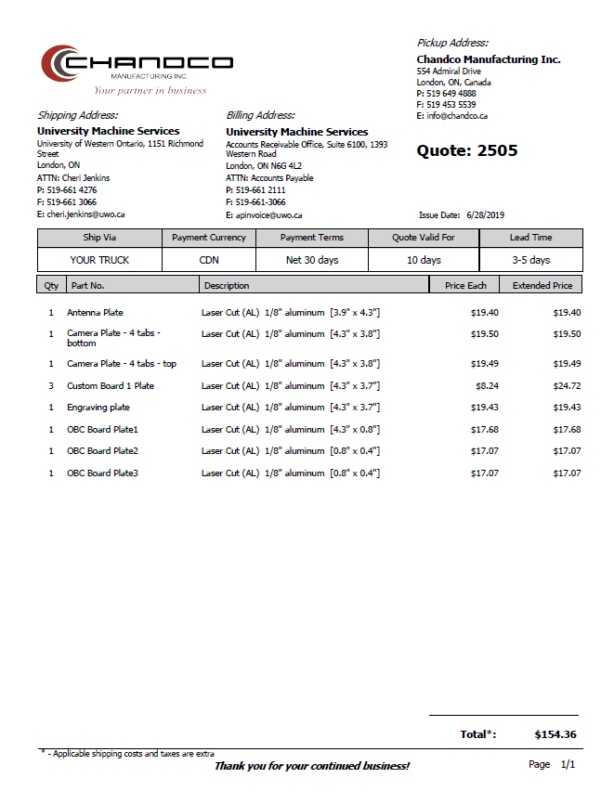

# Appendix I: Mechanical Constraints from Nanoracks

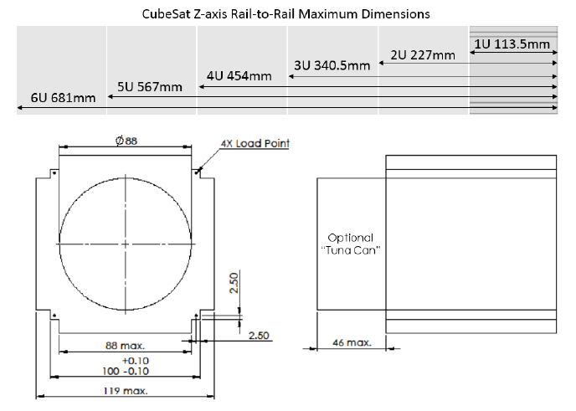 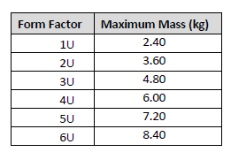 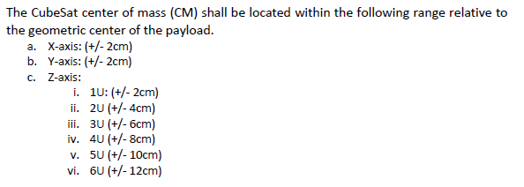 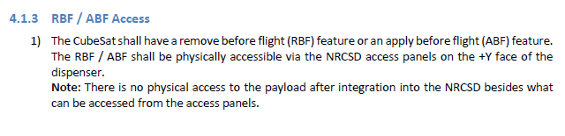 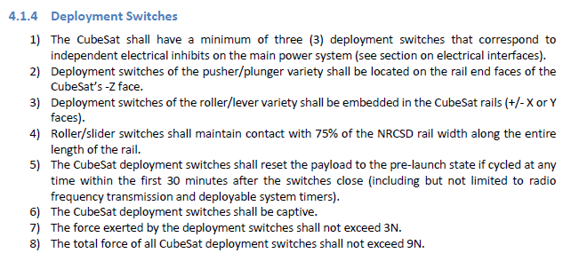 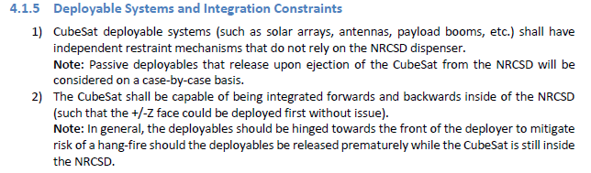

# Appendix II: Electrical constraints from Nanoracks

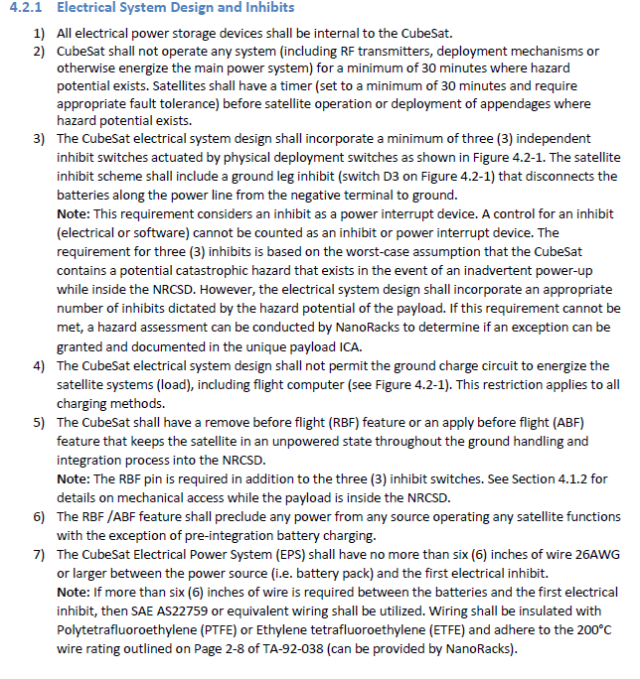

# Appendix III: FEA – Static Gravitational Analysis

We couldn’t get the cubesat to mesh with the entire model, so we used symmetry to only work with a quarter of the model.



Loading – I did all negative directions, Lauren did all positive loading directions.

Added symmetry fixtures to the top plate:



Component contacts: bonded, globally, so all parts cannot go through or pull apart from each other.

Soft springs enabled, as the cubesat would be limited to how far out it could deform. I realize that this is not accurate as the soft springs are very soft and the cubesat would hit the rails of the deployer, but it seemed better than nothing.

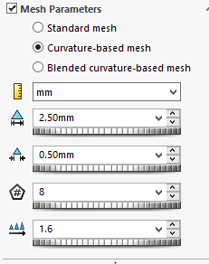

Rail failed so mesh control on outer fillet of 0.15 mm elements and on rail edge faces 0.25 mm.

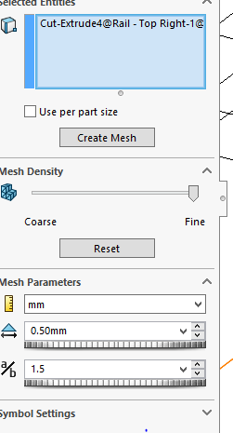

Applied mesh control of 0.5 mm on the bends for the sheet metal. The resulting mesh is shown below. It can be seen that the majority of the components were meshed with solid tetrahedral elements, however the sheet metal structural plates were meshed (automatically) with 2D elements. This is acceptable as the material is relatively thin and it will greatly simplify the mesh, however, it will also introduce inaccuracies if the joints between the solid mesh and the 2d mesh are not aligned properly.

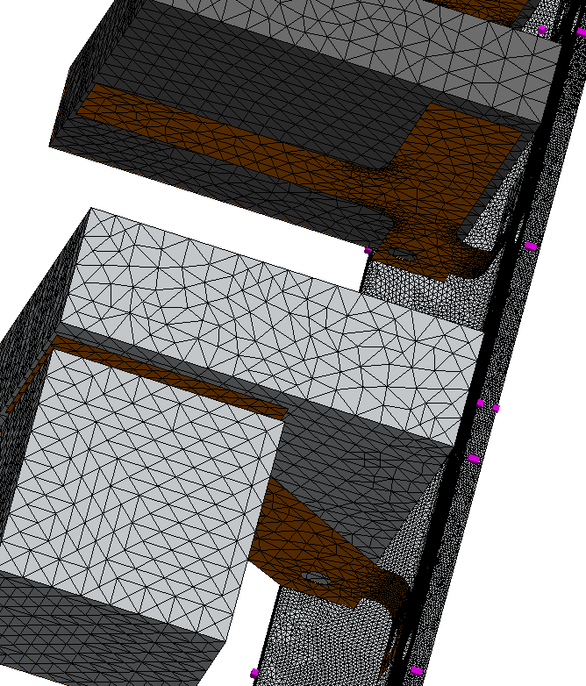

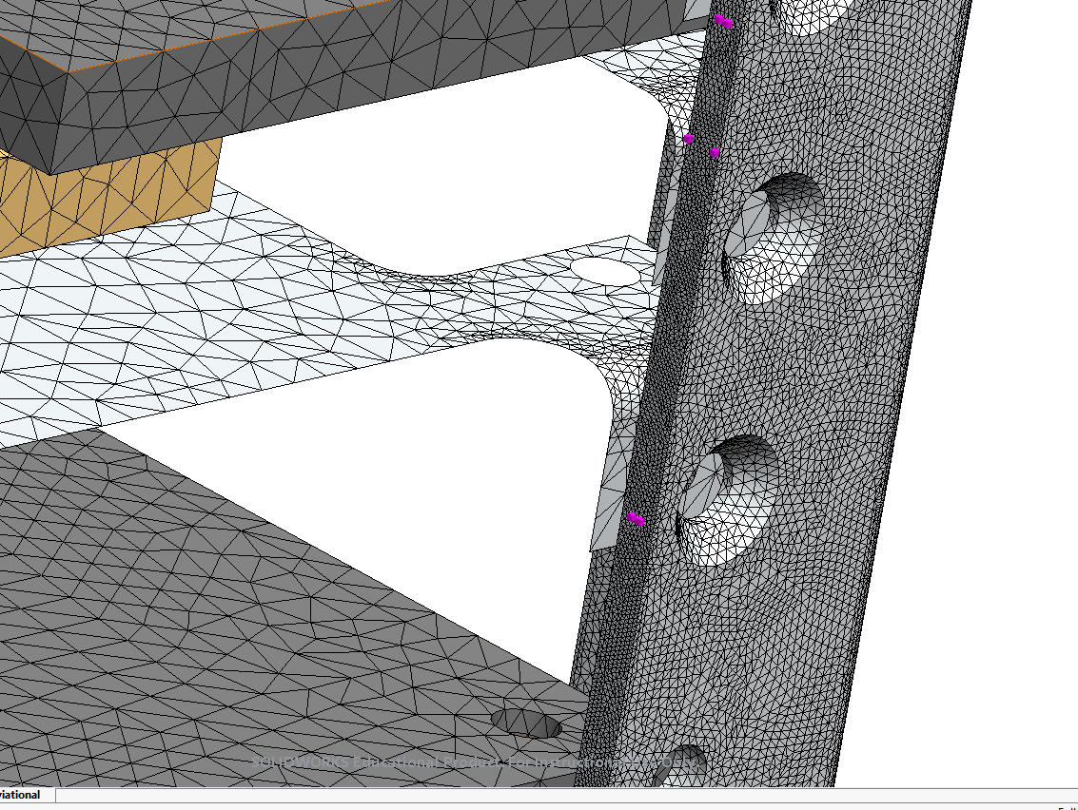

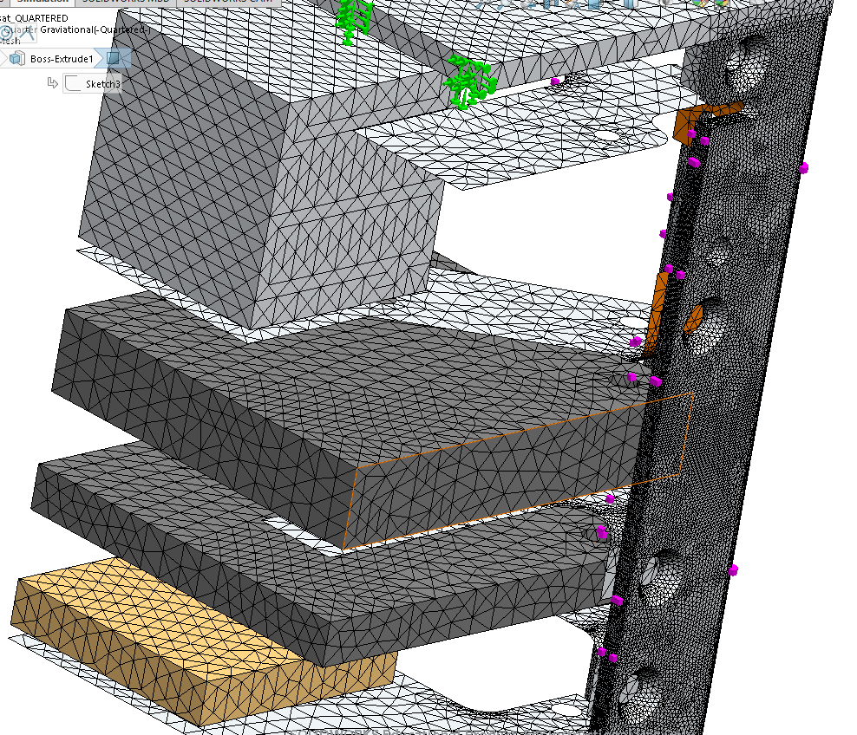

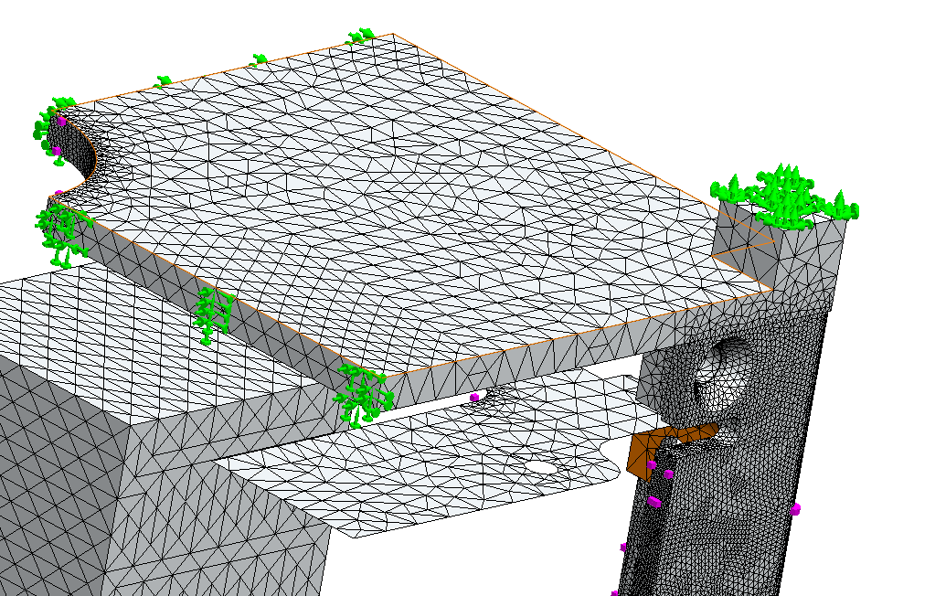

For the

results, I looked at the Von Mises stressed – because it is a ductile material. If the von mises stress is greater than the yield strength, the parts will plastically deform.



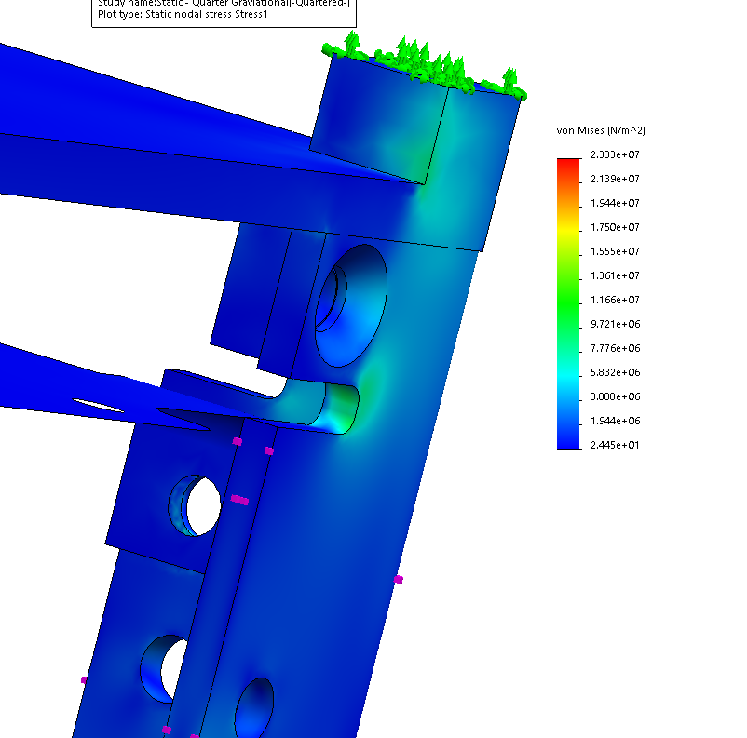

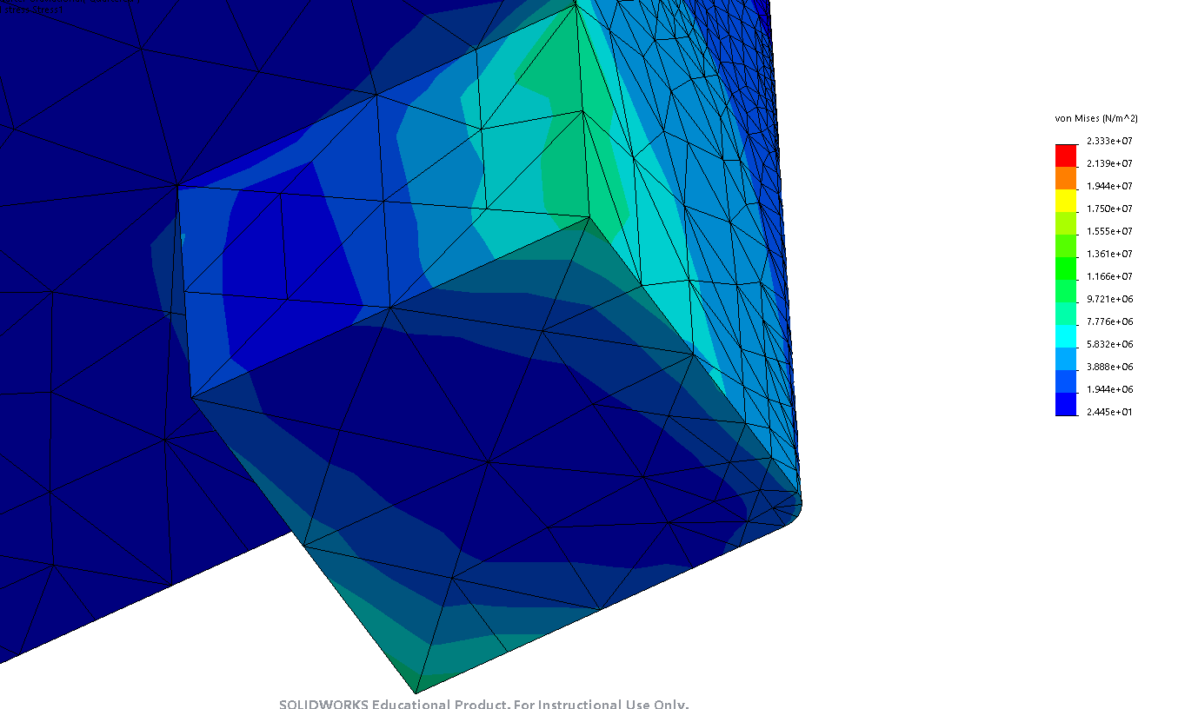

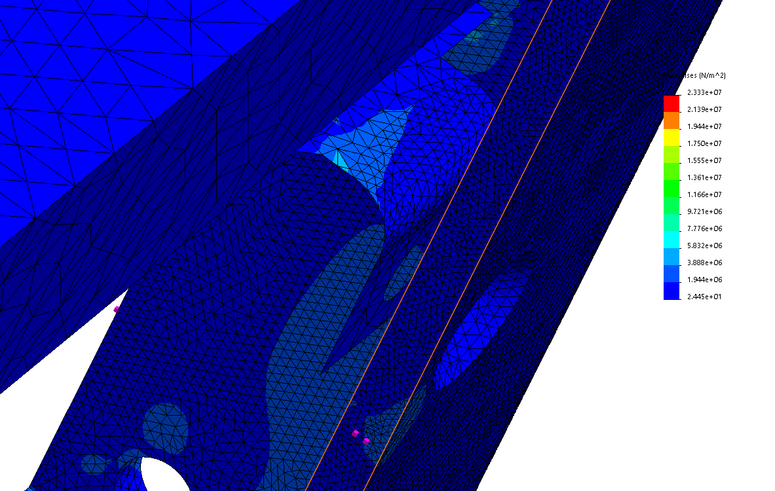

Figure 27: Bottom Camera plate - top side

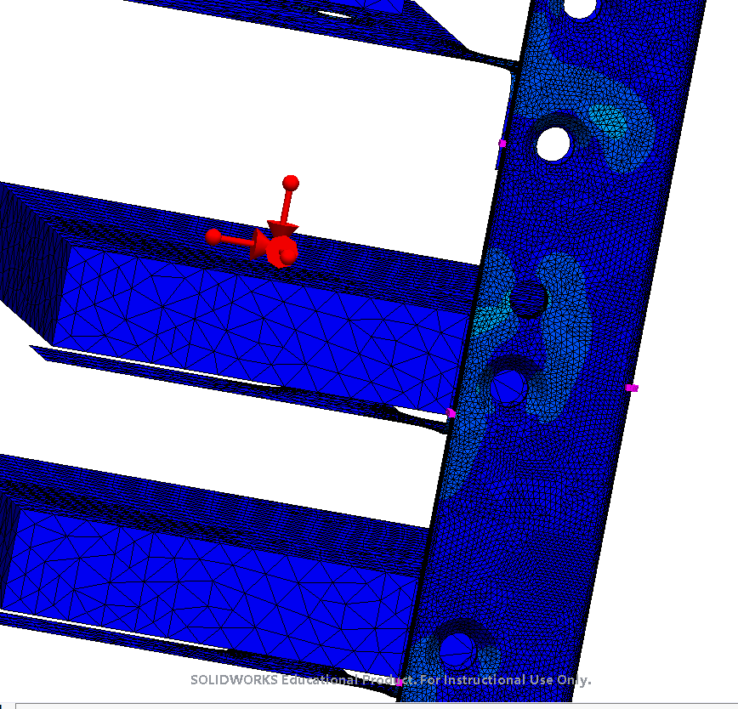

Figure 28: Custom Board Area

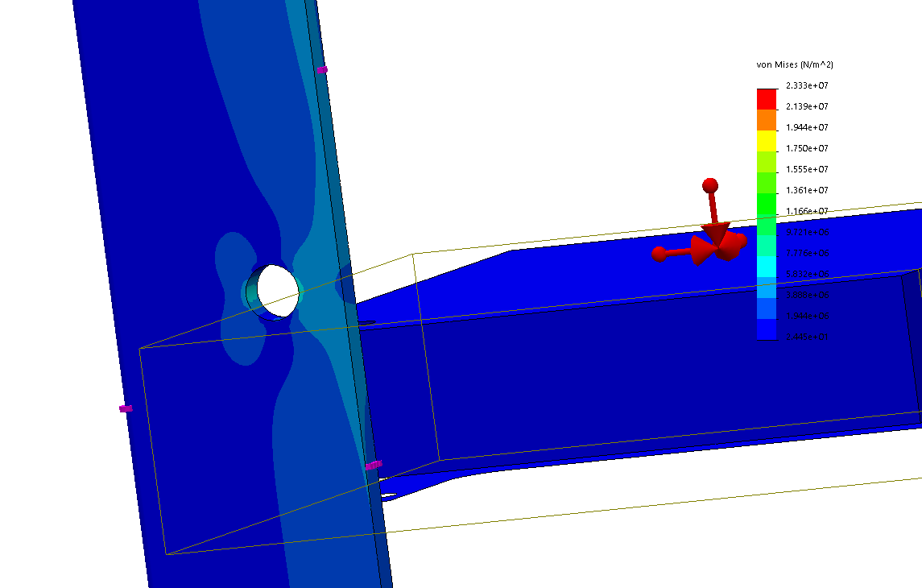

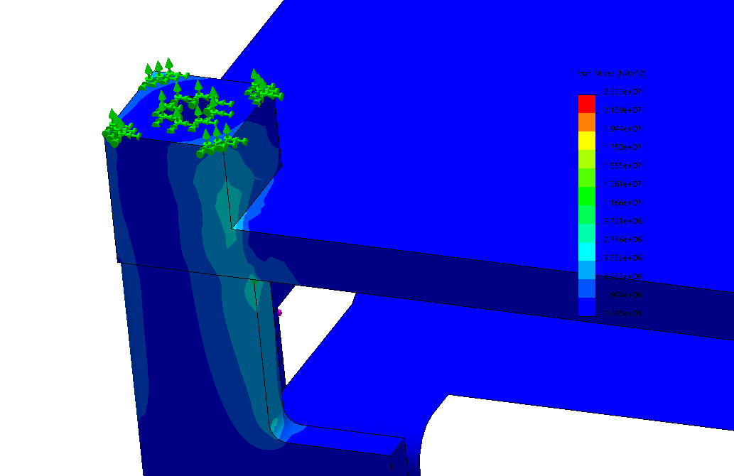

Displacement



Strain:

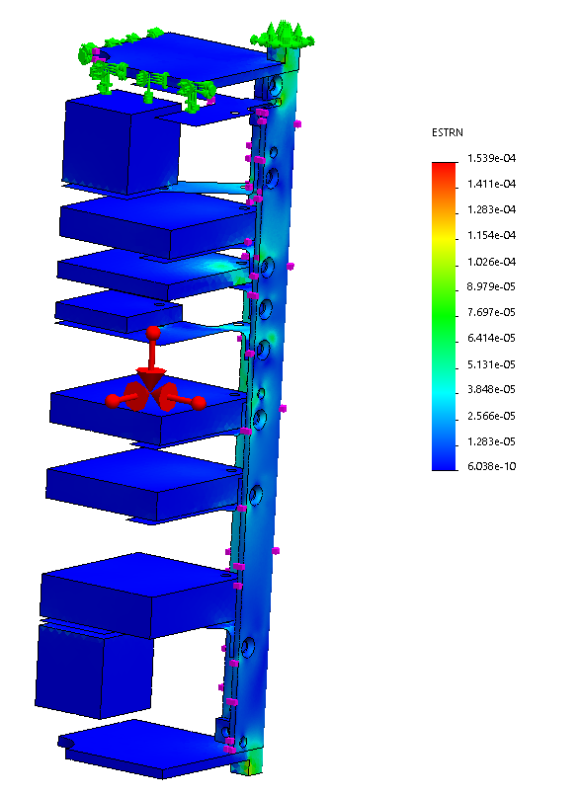

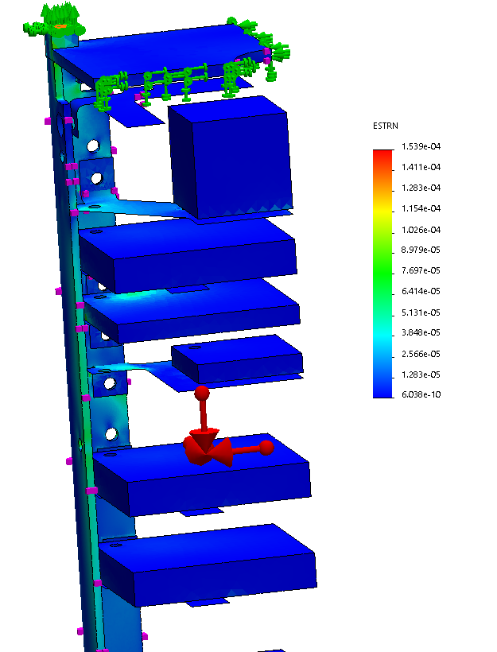

FOS (grey are the parts that are NOT AL 6061-T6)

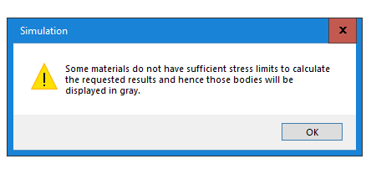

Min FOS is 1.5. Most of it is above FOS = 10. Purple is FOS above 100

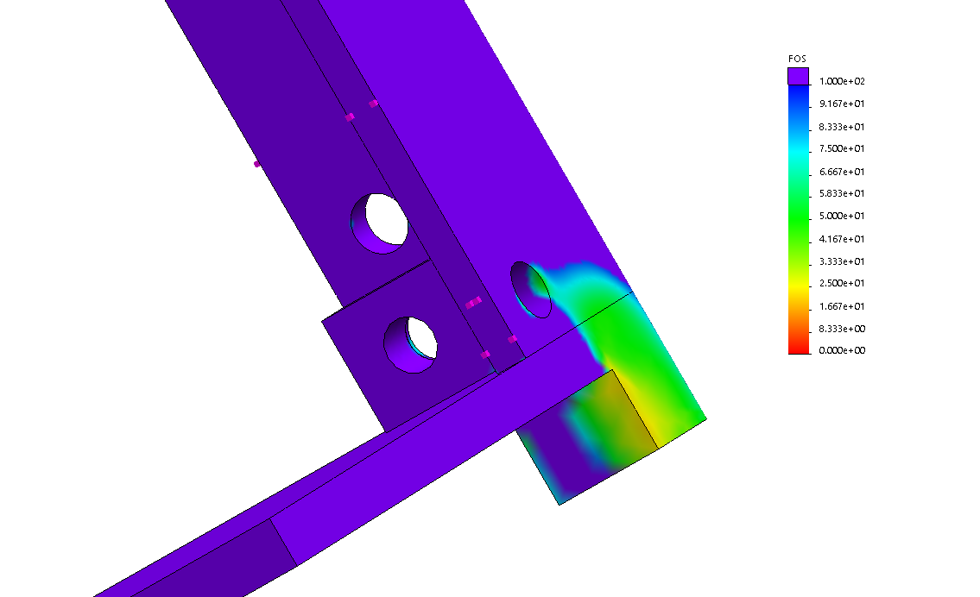

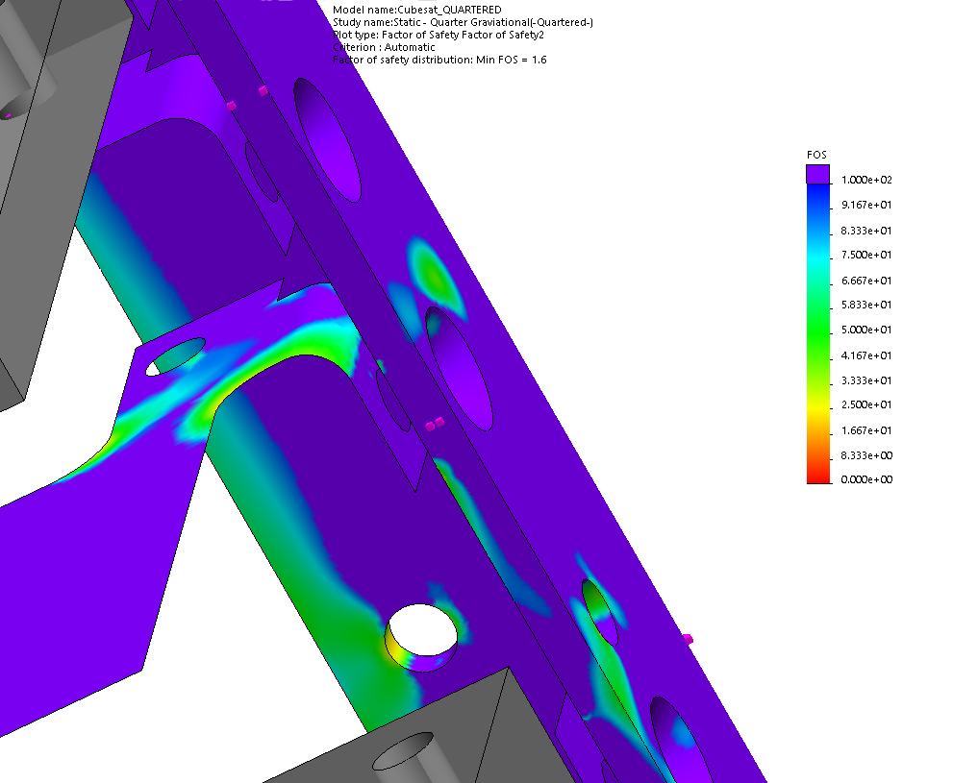

Figure 29: Engraving plate

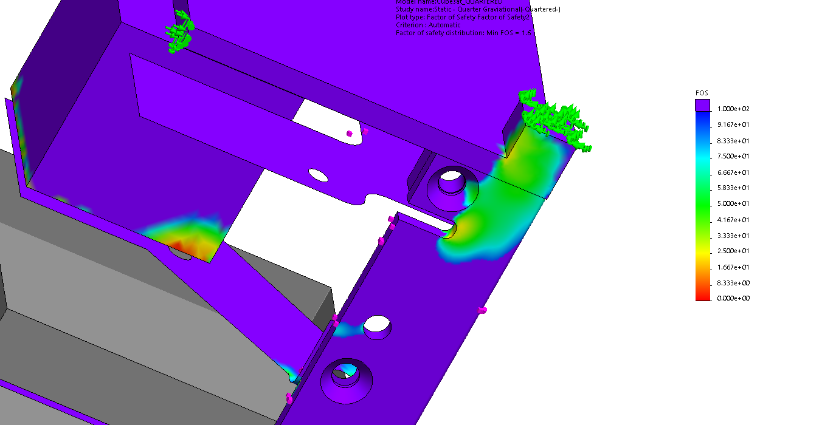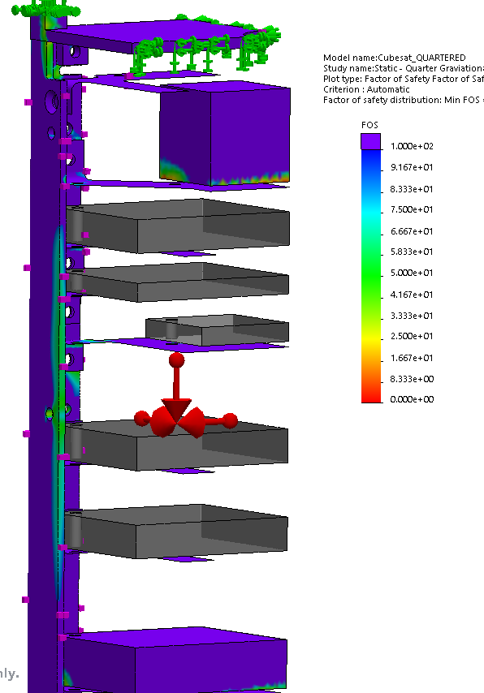



Figure 30: Bottom Camera/esp plate

Von mises at bolt holes:

Bottom

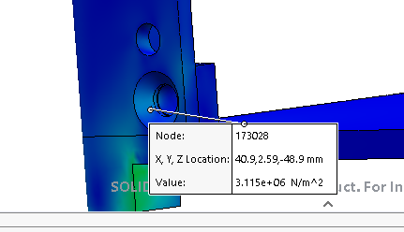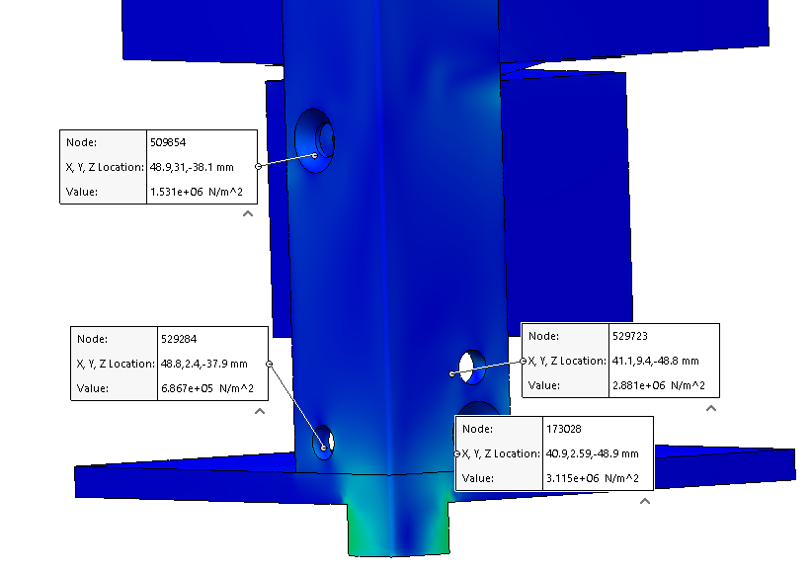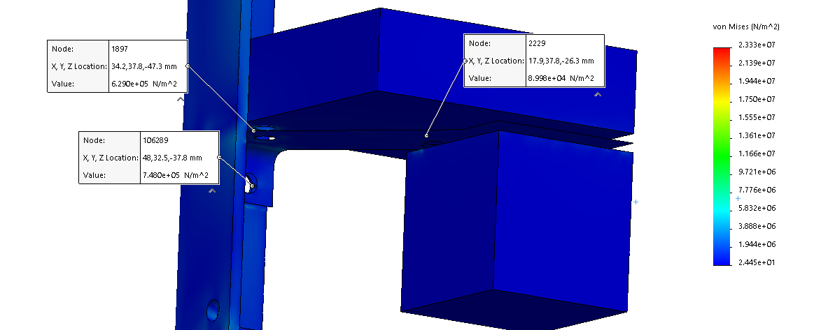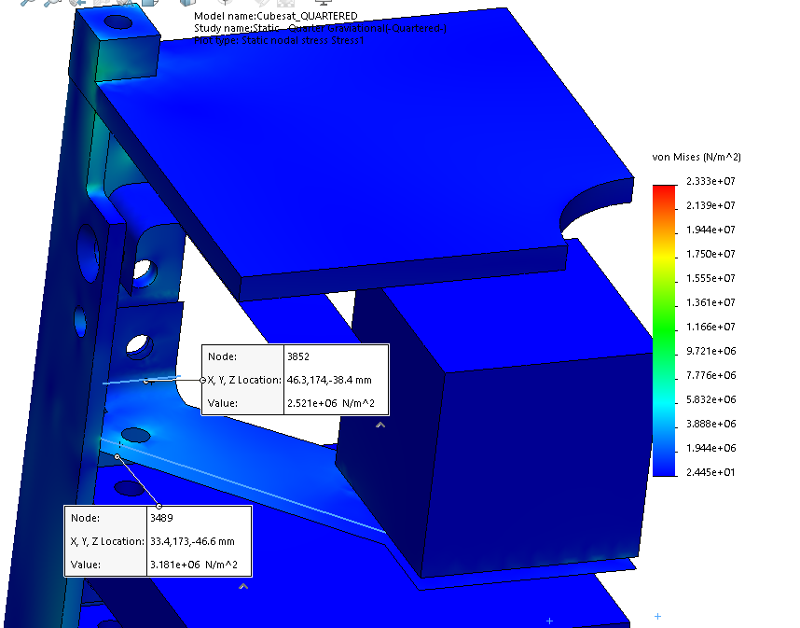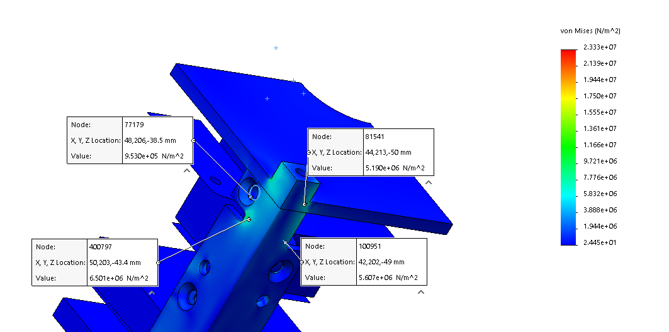

## Gravitational Loads in Opposite Direction

Same mesh and other parameters

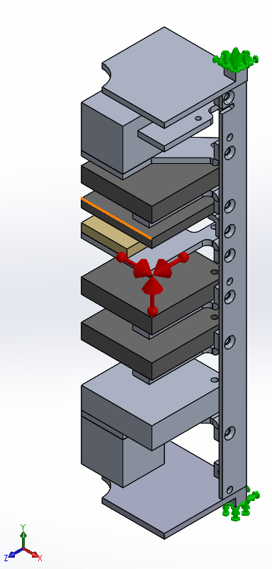

Gravity in positive directions and fixed geometry on end faces of rails.

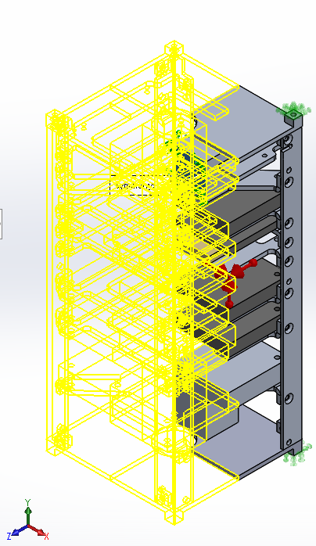

Apply symmetry (fixtures, advanced)

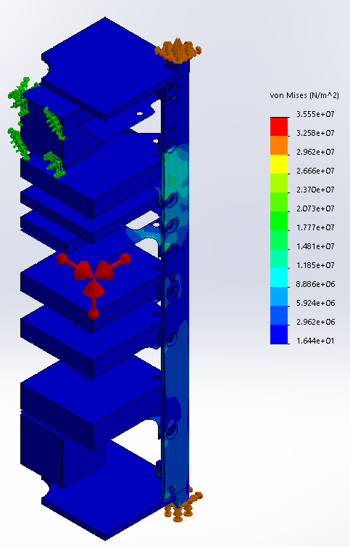

Von Mises stress plot

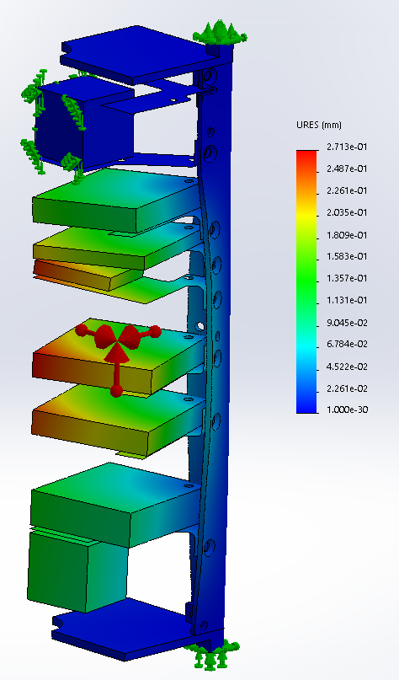

Displacement plot

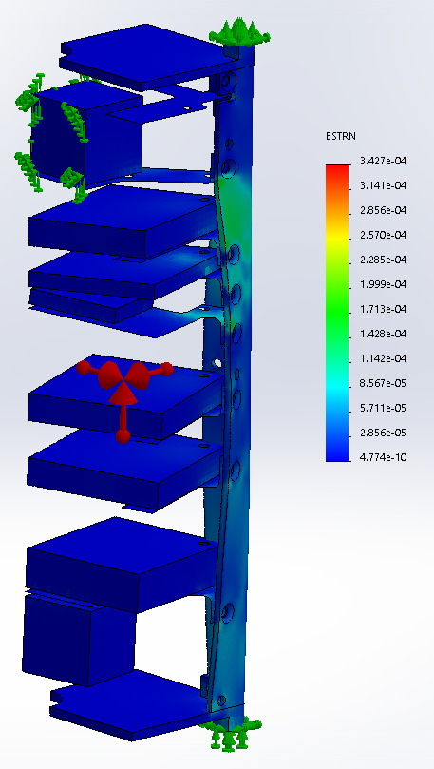

Strain plot

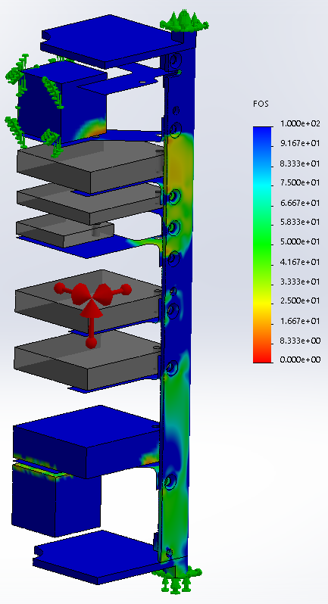

FOS

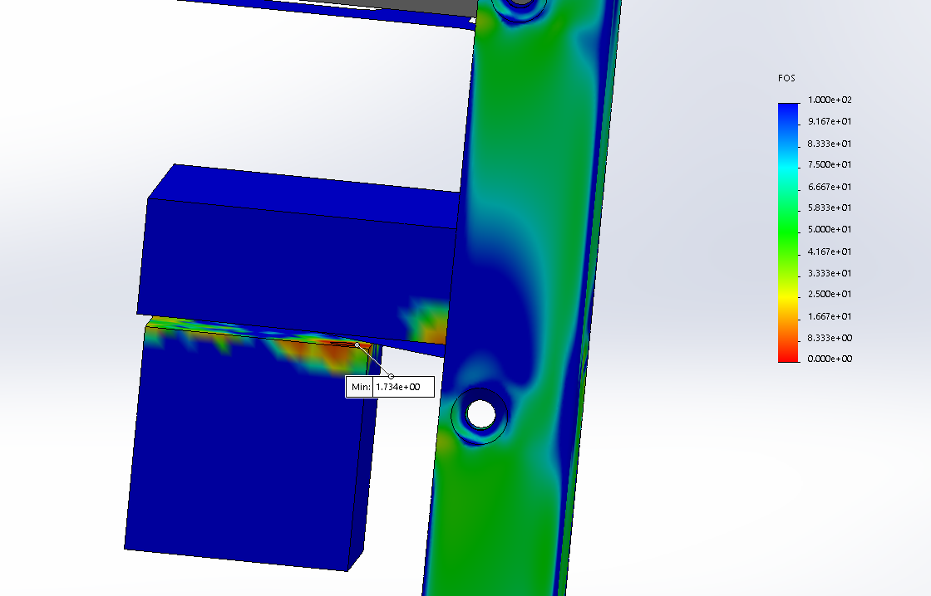

FOS min

## Static Graviational Study – Report Generated by Solidworks

|  |  |
| --- | --- |
| Study name | Static - Quarter Graviational |
| Analysis type | Static |
| Mesh type | Mixed Mesh |
| Thermal Effect: | On |
| Thermal option | Include temperature loads |
| Zero strain temperature | 298 Kelvin |
| Include fluid pressure effects from SOLIDWORKS Flow Simulation | Off |
| Solver type | FFEPlus |
| Inplane Effect: | Off |
| Soft Spring: | On |
| Inertial Relief: | Off |
| Incompatible bonding options | Automatic |
| Large displacement | Off |
| Compute free body forces | On |
| Friction | Off |
| Use Adaptive Method: | Off |
| Result folder | SOLIDWORKS document (\\ebithp-c1v20.eng.uwo.ca\studentdrives\clizotte\desktop\cubesat) |
| Unit system: | SI (MKS) |
| Length/Displacement | mm |
| Temperature | Kelvin |
| Angular velocity | Rad/sec |
| Pressure/Stress | N/m^2 |

|  |  |  |
| --- | --- | --- |
| **Model Reference** | **Properties** | **Components** |
|  | |  |  | | --- | --- | | **Name:** | **6061-T6 (SS)** | | **Model type:** | **Linear Elastic Isotropic** | | **Default failure criterion:** | **Unknown** | | **Yield strength:** | **2.75e+08 N/m^2** | | **Tensile strength:** | **3.1e+08 N/m^2** | | **Elastic modulus:** | **6.9e+10 N/m^2** | | **Poisson's ratio:** | **0.33** | | **Mass density:** | **2700 kg/m^3** | | **Shear modulus:** | **2.6e+10 N/m^2** | | **Thermal expansion coefficient:** | **2.4e-05 /Kelvin** | | **SolidBody 1(Cut-Extrude2)(Antenna Plate-1),**  **SolidBody 1(Cut-Extrude5)(Camera Plate - 4 tabs - bottom-1),**  **SolidBody 1(Cut-Extrude5)(Camera Plate - 4 tabs - top-1),**  **SolidBody 1(Fillet1)(Cover Plate Bottom-1),**  **SolidBody 1(Cut-Extrude5)(Cover Plate Top-2),**  **SolidBody 1(Cut-Extrude2)(Custom Board 1 Plate-1),**  **SolidBody 1(Cut-Extrude2)(Custom Board 1 Plate-2),**  **SolidBody 1(Cut-Extrude2)(Custom Plate - tabs down-1),**  **SolidBody 1(Cut-Extrude3)(Engraving plate-1),**  **SolidBody 1(Cut-Extrude4[1])(OBC Board Plate-1),**  **SolidBody 1(Cut-Extrude4)(Rail - Top Right-1)** |
| **Curve Data:N/A** | | |
|  | |  |  | | --- | --- | | **Name:** | **1060 Alloy** | | **Model type:** | **Linear Elastic Isotropic** | | **Default failure criterion:** | **Unknown** | | **Yield strength:** | **2.75742e+07 N/m^2** | | **Tensile strength:** | **6.89356e+07 N/m^2** | | **Elastic modulus:** | **6.9e+10 N/m^2** | | **Poisson's ratio:** | **0.33** | | **Mass density:** | **2700 kg/m^3** | | **Shear modulus:** | **2.7e+10 N/m^2** | | **Thermal expansion coefficient:** | **2.4e-05 /Kelvin** | | **SolidBody 1(Cut-Extrude1)(Camera for FEA-1),**  **SolidBody 1(Cut-Extrude1)(Camera for FEA-2),**  **SolidBody 1(Boss-Extrude1)(fake esp for fea-1)** |
| **Curve Data:N/A** | | |
|  | |  |  | | --- | --- | | **Name:** | **Pure Gold** | | **Model type:** | **Linear Elastic Isotropic** | | **Default failure criterion:** | **Unknown** | | **Tensile strength:** | **1.03e+08 N/m^2** | | **Elastic modulus:** | **7.8e+10 N/m^2** | | **Poisson's ratio:** | **0.42** | | **Mass density:** | **19000 kg/m^3** | | **Shear modulus:** | **2.6e+10 N/m^2** | | **Thermal expansion coefficient:** | **1.4e-05 /Kelvin** | | **SolidBody 1(Cut-Extrude1)(Engraving-1)** |
| **Curve Data:N/A** | | |
|  | |  |  | | --- | --- | | **Name:** | **PBT General Purpose** | | **Model type:** | **Linear Elastic Isotropic** | | **Default failure criterion:** | **Unknown** | | **Tensile strength:** | **5.65e+07 N/m^2** | | **Elastic modulus:** | **1.93e+09 N/m^2** | | **Poisson's ratio:** | **0.3902** | | **Mass density:** | **1300 kg/m^3** | | **Shear modulus:** | **6.902e+08 N/m^2** | | **SolidBody 1(Boss-Extrude1)(fake custom board 1 for fea-1),**  **SolidBody 1(Boss-Extrude1)(fake custom board 1 for fea-2),**  **SolidBody 1(Boss-Extrude1)(fake obc for fea-1),**  **SolidBody 1(Boss-Extrude1)(fake transceiver for fea-1)** |
| **Curve Data:N/A** | | |

|  |  |  |  |  |  |  |  |  |  |  |  |  |  |  |  |  |  |  |  |  |  |  |  |  |
| --- | --- | --- | --- | --- | --- | --- | --- | --- | --- | --- | --- | --- | --- | --- | --- | --- | --- | --- | --- | --- | --- | --- | --- | --- |
| Resultant ForcesReaction forces  | Selection set | Units | Sum X | Sum Y | Sum Z | Resultant | | --- | --- | --- | --- | --- | --- | | Entire Model | N | 30.405 | 17.374 | 17.3743 | 39.092 |  Reaction Moments  | Selection set | Units | Sum X | Sum Y | Sum Z | Resultant | | --- | --- | --- | --- | --- | --- | | Entire Model | N.m | 0 | 0 | 0 | 1e-33 | |

#### Study Results

| Name | Type | Min | Max |
| --- | --- | --- | --- |
| Stress1 | VON: von Mises Stress | 2.445e+01 N/m^2  Node: 1551599 | 2.333e+07 N/m^2  Node: 96467 |
| **Cubesat_QUARTERED-Static - Quarter Graviational-Stress-Stress1** | | | |

| Name | Type | Min | Max |
| --- | --- | --- | --- |
| Displacement1 | URES: Resultant Displacement | 0.000e+00 mm  Node: 47159 | 9.133e-02 mm  Node: 1551448 |
| **Cubesat_QUARTERED-Static - Quarter Graviational-Displacement-Displacement1** | | | |

| Name | Type | Min | Max |
| --- | --- | --- | --- |
| Strain1 | ESTRN: Equivalent Strain | 6.038e-10  Element: 39515 | 1.539e-04  Element: 816509 |
| **Cubesat_QUARTERED-Static - Quarter Graviational-Strain-Strain1** | | | |

| Name | Type |
| --- | --- |
| Displacement1{1} | Deformed shape |
| **Cubesat_QUARTERED-Static - Quarter Graviational-Displacement-Displacement1{1}** | |

| Name | Type | Min | Max |
| --- | --- | --- | --- |
| Factor of Safety1 | Automatic | 1.562e+00  Node: 33831 | 3.726e+06  Node: 67963 |
| **Cubesat_QUARTERED-Static - Quarter Graviational-Factor of Safety-Factor of Safety1** | | | |

# Appendix IV: Modal Analysis

Frequency – modal analysis.

There didn’t’ seem to be the harmonic analysis that the capstone team apparently did. Not sure where that was.

But the frequency analysis seems to give the natural frequencies. There seems to be a lot close together, probably because of all the plates to hold the components.

I don’t think this study was done properly.

I used the same mesh and load (gravity – the vibrations will be during launch, and symmetry). 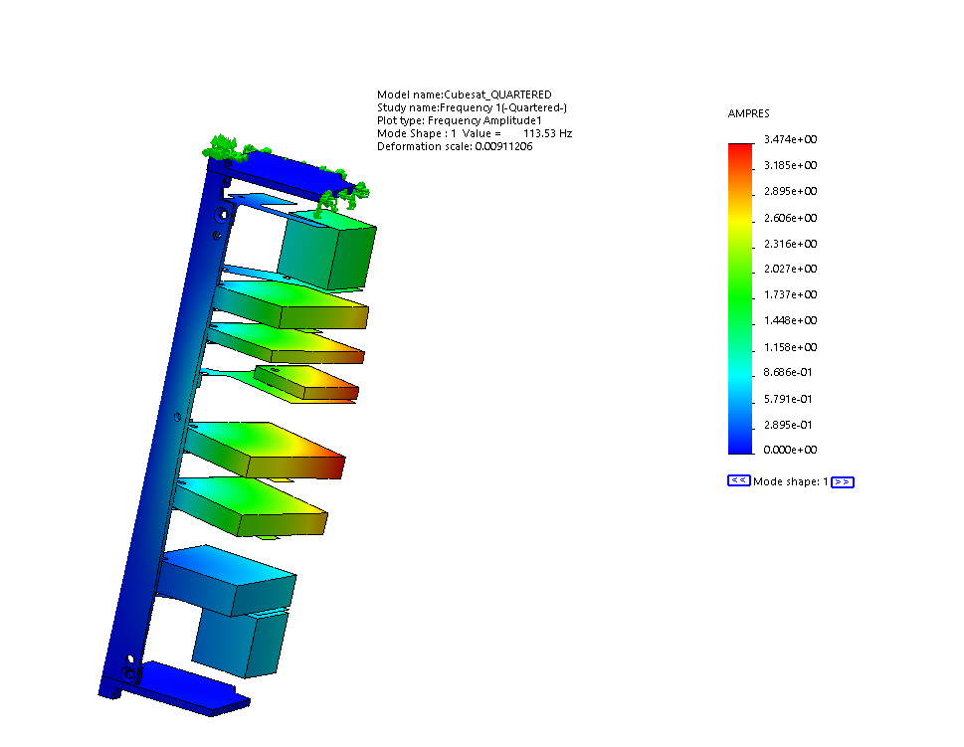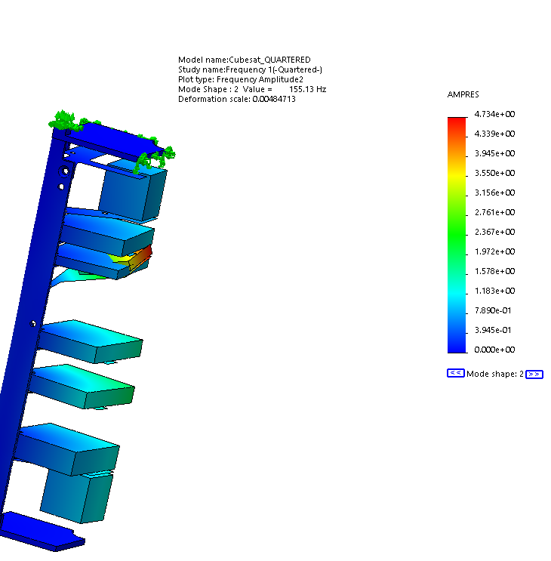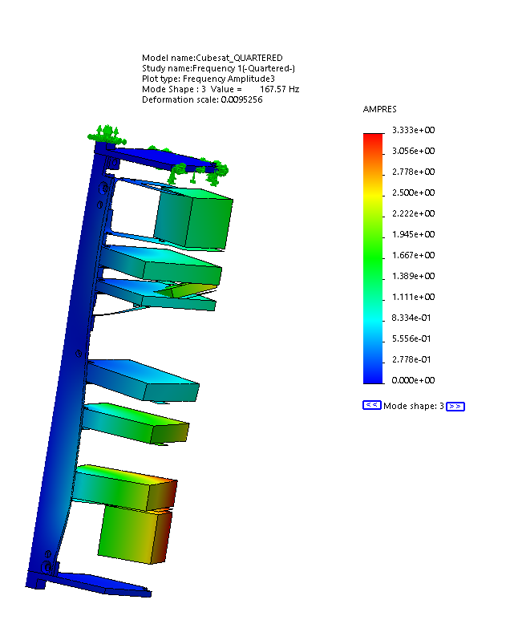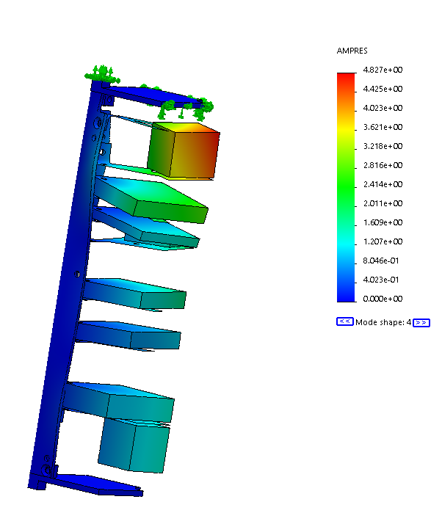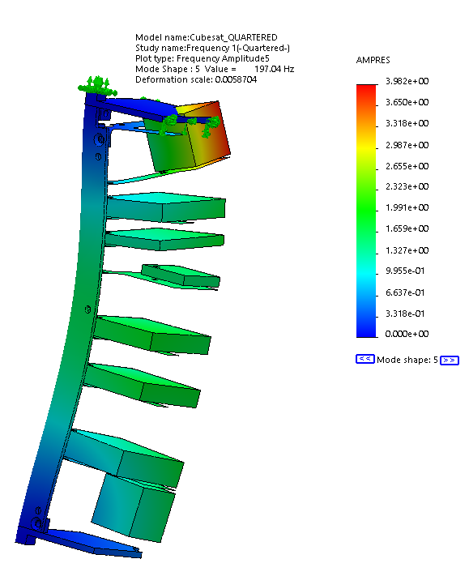

## Modal Analysis – Solidworks Report

|  |  |  |  |  |  |  |  |  |  |  |  |  |  |  |  |  |  |  |  |  |  |  |
| --- | --- | --- | --- | --- | --- | --- | --- | --- | --- | --- | --- | --- | --- | --- | --- | --- | --- | --- | --- | --- | --- | --- |
| Study Properties  |  |  | | --- | --- | | Study name | Frequency 1 | | Analysis type | Frequency | | Mesh type | Mixed Mesh | | Number of frequencies | 5 | | Solver type | FFEPlus | | Soft Spring: | Off | | Incompatible bonding options | Automatic | | Thermal option | Include temperature loads | | Zero strain temperature | 298 Kelvin | | Include fluid pressure effects from SOLIDWORKS Flow Simulation | Off | | Result folder | SOLIDWORKS document (\\ebithp-c1v20.eng.uwo.ca\studentdrives\clizotte\desktop\cubesat) | |

|  |  |  |  |  |  |  |  |  |  |  |
| --- | --- | --- | --- | --- | --- | --- | --- | --- | --- | --- |
| Units  |  |  | | --- | --- | | Unit system: | SI (MKS) | | Length/Displacement | mm | | Temperature | Kelvin | | Angular velocity | Rad/sec | | Pressure/Stress | N/m^2 | |

|  |  |  |  |  |  |  |  |  |  |  |  |  |  |  |  |  |  |  |  |  |  |  |  |  |  |  |  |  |  |  |  |  |  |  |  |  |  |  |  |  |  |  |  |  |  |  |  |  |  |  |  |  |  |  |  |  |  |  |  |  |  |  |  |  |  |  |  |  |  |  |  |  |  |  |  |  |  |  |  |  |  |  |  |  |  |  |  |  |  |  |  |  |  |
| --- | --- | --- | --- | --- | --- | --- | --- | --- | --- | --- | --- | --- | --- | --- | --- | --- | --- | --- | --- | --- | --- | --- | --- | --- | --- | --- | --- | --- | --- | --- | --- | --- | --- | --- | --- | --- | --- | --- | --- | --- | --- | --- | --- | --- | --- | --- | --- | --- | --- | --- | --- | --- | --- | --- | --- | --- | --- | --- | --- | --- | --- | --- | --- | --- | --- | --- | --- | --- | --- | --- | --- | --- | --- | --- | --- | --- | --- | --- | --- | --- | --- | --- | --- | --- | --- | --- | --- | --- | --- | --- | --- | --- | --- |
| Material Properties  |  |  |  | | --- | --- | --- | | **Model Reference** | **Properties** | **Components** | |  | |  |  | | --- | --- | | **Name:** | **6061-T6 (SS)** | | **Model type:** | **Linear Elastic Isotropic** | | **Default failure criterion:** | **Unknown** | | **Yield strength:** | **2.75e+08 N/m^2** | | **Tensile strength:** | **3.1e+08 N/m^2** | | **Mass density:** | **2700 kg/m^3** | | **Elastic modulus:** | **6.9e+10 N/m^2** | | **Poisson's ratio:** | **0.33** | | **Thermal expansion coefficient:** | **2.4e-05 /Kelvin** | | **SolidBody 1(Cut-Extrude2)(Antenna Plate-1),**  **SolidBody 1(Cut-Extrude5)(Camera Plate - 4 tabs - bottom-1),**  **SolidBody 1(Cut-Extrude5)(Camera Plate - 4 tabs - top-1),**  **SolidBody 1(Fillet1)(Cover Plate Bottom-1),**  **SolidBody 1(Cut-Extrude5)(Cover Plate Top-2),**  **SolidBody 1(Cut-Extrude2)(Custom Board 1 Plate-1),**  **SolidBody 1(Cut-Extrude2)(Custom Board 1 Plate-2),**  **SolidBody 1(Cut-Extrude2)(Custom Plate - tabs down-1),**  **SolidBody 1(Cut-Extrude3)(Engraving plate-1),**  **SolidBody 1(Cut-Extrude4[1])(OBC Board Plate-1),**  **SolidBody 1(Cut-Extrude4)(Rail - Top Right-1)** | | **Curve Data:N/A** | | | |  | |  |  | | --- | --- | | **Name:** | **1060 Alloy** | | **Model type:** | **Linear Elastic Isotropic** | | **Default failure criterion:** | **Unknown** | | **Yield strength:** | **2.75742e+07 N/m^2** | | **Tensile strength:** | **6.89356e+07 N/m^2** | | **Mass density:** | **2700 kg/m^3** | | **Elastic modulus:** | **6.9e+10 N/m^2** | | **Poisson's ratio:** | **0.33** | | **Thermal expansion coefficient:** | **2.4e-05 /Kelvin** | | **SolidBody 1(Cut-Extrude1)(Camera for FEA-1),**  **SolidBody 1(Cut-Extrude1)(Camera for FEA-2),**  **SolidBody 1(Boss-Extrude1)(fake esp for fea-1)** | | **Curve Data:N/A** | | | |  | |  |  | | --- | --- | | **Name:** | **Pure Gold** | | **Model type:** | **Linear Elastic Isotropic** | | **Default failure criterion:** | **Unknown** | | **Tensile strength:** | **1.03e+08 N/m^2** | | **Mass density:** | **19000 kg/m^3** | | **Elastic modulus:** | **7.8e+10 N/m^2** | | **Poisson's ratio:** | **0.42** | | **Thermal expansion coefficient:** | **1.4e-05 /Kelvin** | | **SolidBody 1(Cut-Extrude1)(Engraving-1)** | | **Curve Data:N/A** | | | |  | |  |  | | --- | --- | | **Name:** | **PBT General Purpose** | | **Model type:** | **Linear Elastic Isotropic** | | **Default failure criterion:** | **Unknown** | | **Tensile strength:** | **5.65e+07 N/m^2** | | **Mass density:** | **1300 kg/m^3** | | **Elastic modulus:** | **1.93e+09 N/m^2** | | **Poisson's ratio:** | **0.3902** | | **SolidBody 1(Boss-Extrude1)(fake custom board 1 for fea-1),**  **SolidBody 1(Boss-Extrude1)(fake custom board 1 for fea-2),**  **SolidBody 1(Boss-Extrude1)(fake obc for fea-1),**  **SolidBody 1(Boss-Extrude1)(fake transceiver for fea-1)** | | **Curve Data:N/A** | | | |

|  |  |  |  |  |  |  |  |  |  |  |  |  |  |  |  |  |  |  |  |  |  |  |  |  |
| --- | --- | --- | --- | --- | --- | --- | --- | --- | --- | --- | --- | --- | --- | --- | --- | --- | --- | --- | --- | --- | --- | --- | --- | --- |
| **Loads and Fixtures**  | **Fixture name** | **Fixture Image** | **Fixture Details** | | --- | --- | --- | | **Fixed-1** |  | |  |  | | --- | --- | | Entities: | **2 face(s)** | | Type: | **Fixed Geometry** | | | **Symmetry-1** |  | |  |  | | --- | --- | | Entities: | **1 face(s)** | | Type: | **Symmetry** | | | **Symmetry-2** |  | |  |  | | --- | --- | | Entities: | **1 face(s)** | | Type: | **Symmetry** | | |

|  |  |  |  |  |  |  |  |  |  |  |  |  |
| --- | --- | --- | --- | --- | --- | --- | --- | --- | --- | --- | --- | --- |
| Connector Definitions No data. Contact Information  | Contact | Contact Image | Contact Properties | | --- | --- | --- | | Global Contact |  | |  |  | | --- | --- | | Type: | **Bonded** | | Components: | **1 component(s)** | | Options: | **Compatible mesh** | | |
| Mesh information  |  |  | | --- | --- | | Mesh type | Mixed Mesh | | Mesher Used: | Curvature-based mesh | | Jacobian points | 4 Points | | Jacobian check for shell | On | | Maximum element size | 2.5 mm | | Minimum element size | 0.5 mm | | Mesh Quality Plot | High | | Remesh failed parts with incompatible mesh | On |  Mesh information - Details  |  |  | | --- | --- | | Total Nodes | 1640121 | | Total Elements | 1092182 | | Time to complete mesh(hh;mm;ss): | 00:01:02 | | Computer name: | WE-L-ITG-0064 | |  | |  Mesh Control Information:  | **Mesh Control Name** | **Mesh Control Image** | **Mesh Control Details** | | --- | --- | --- | | **Control-1** |  | |  |  | | --- | --- | | Entities: | **1 face(s)** | | Units: | **mm** | | Size: | **0.25** | | Ratio: | **1.5** | | | **Control-2** |  | |  |  | | --- | --- | | Entities: | **2 face(s)** | | Units: | **mm** | | Size: | **0.25** | | Ratio: | **1.5** | | | **Control-3** |  | |  |  | | --- | --- | | Entities: | **1 Solid Body (s)** | | Units: | **mm** | | Size: | **0.5** | | Ratio: | **1.5** | | | **Control-4** |  | |  |  | | --- | --- | | Entities: | **14 face(s)** | | Units: | **mm** | | Size: | **0.5** | | Ratio: | **1.5** | | | **Control-5** |  | |  |  | | --- | --- | | Entities: | **14 face(s)** | | Units: | **mm** | | Size: | **0.5** | | Ratio: | **1.5** | | |

|  |
| --- |
| Sensor Details No Data |

|  |  |  |  |  |  |  |  |  |  |  |  |  |  |  |  |  |  |  |  |  |  |  |  |  |  |  |  |  |  |  |  |  |  |  |  |  |  |  |  |  |  |  |  |  |  |  |  |  |  |  |  |  |  |  |  |  |  |  |  |  |  |  |  |  |  |  |  |  |  |  |  |  |  |  |  |  |  |  |  |  |  |  |  |  |  |  |  |  |  |  |  |  |  |  |  |  |  |  |  |  |  |  |  |  |  |  |  |  |  |  |  |  |  |  |  |  |  |  |  |
| --- | --- | --- | --- | --- | --- | --- | --- | --- | --- | --- | --- | --- | --- | --- | --- | --- | --- | --- | --- | --- | --- | --- | --- | --- | --- | --- | --- | --- | --- | --- | --- | --- | --- | --- | --- | --- | --- | --- | --- | --- | --- | --- | --- | --- | --- | --- | --- | --- | --- | --- | --- | --- | --- | --- | --- | --- | --- | --- | --- | --- | --- | --- | --- | --- | --- | --- | --- | --- | --- | --- | --- | --- | --- | --- | --- | --- | --- | --- | --- | --- | --- | --- | --- | --- | --- | --- | --- | --- | --- | --- | --- | --- | --- | --- | --- | --- | --- | --- | --- | --- | --- | --- | --- | --- | --- | --- | --- | --- | --- | --- | --- | --- | --- | --- | --- | --- | --- | --- | --- |
| Study Results  | Name | Type | Min | Max | | --- | --- | --- | --- | | Amplitude1 | AMPRES: Resultant Amplitude Plot for Mode Shape: 1(Value = 113.532 Hz) | 0.000e+00  Node: 47159 | 3.474e+00  Node: 1551448 | | **Cubesat_QUARTERED-Frequency 1-Amplitude-Amplitude1** | | | |  | Name | Type | Min | Max | | --- | --- | --- | --- | | Amplitude2 | AMPRES: Resultant Amplitude Plot for Mode Shape: 2(Value = 155.134 Hz) | 0.000e+00  Node: 47159 | 4.734e+00  Node: 95613 | | **Cubesat_QUARTERED-Frequency 1-Amplitude-Amplitude2** | | | |  | Name | Type | Min | Max | | --- | --- | --- | --- | | Amplitude3 | AMPRES: Resultant Amplitude Plot for Mode Shape: 3(Value = 167.57 Hz) | 0.000e+00  Node: 47159 | 3.333e+00  Node: 1585961 | | **Cubesat_QUARTERED-Frequency 1-Amplitude-Amplitude3** | | | |  | Name | Type | Min | Max | | --- | --- | --- | --- | | Amplitude4 | AMPRES: Resultant Amplitude Plot for Mode Shape: 4(Value = 189.711 Hz) | 0.000e+00  Node: 47159 | 4.827e+00  Node: 15954 | | **Cubesat_QUARTERED-Frequency 1-Amplitude-Amplitude4** | | | |  | Name | Type | Min | Max | | --- | --- | --- | --- | | Amplitude5 | AMPRES: Resultant Amplitude Plot for Mode Shape: 5(Value = 197.036 Hz) | 0.000e+00  Node: 47159 | 3.982e+00  Node: 15954 | | **Cubesat_QUARTERED-Frequency 1-Amplitude-Amplitude5** | | | |   **Mode List**   | **Frequency Number** | **Rad/sec** | **Hertz** | **Seconds** | | --- | --- | --- | --- | | **1** | **713.34** | **113.53** | **0.0088081** | | **2** | **974.74** | **155.13** | **0.006446** | | **3** | **1052.9** | **167.57** | **0.0059677** | | **4** | **1192** | **189.71** | **0.0052712** | | **5** | **1238** | **197.04** | **0.0050752** |   **Mass Participation (Normalized)**   | **Mode Number** | **Frequency(Hertz)** | **X direction** | **Y direction** | **Z direction** | | --- | --- | --- | --- | --- | | **1** | **113.53** | **0.30869** | **5.5193e-07** | **0.29661** | | **2** | **155.13** | **0.0066575** | **0.13262** | **0.002823** | | **3** | **167.57** | **0.035887** | **0.025379** | **0.027765** | | **4** | **189.71** | **0.029267** | **0.000177** | **0.040201** | | **5** | **197.04** | **0.16179** | **0.0017025** | **0.17141** | |  |  | **Sum X = 0.54229** | **Sum Y = 0.15988** | **Sum Z = 0.53881** | |